LO: To use geographical language to write a postcard.
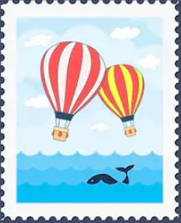
Dear

A postcard from
__________________________________

