Nicknamed the ‘City of Light’, Paris is an elegant and time-honoured city with a rich cultural history and classic spirit. Everything about the capital oozes elegance, from its world-famous landmarks and rich art history, to its fine dining and luxury fashion.  Discover iconic artefacts at the Musée du Louvre, enjoy a picnic lunch at Luxembourg Gardens, or fall in love while looking out over the city’s moonlit landscape on top of the Eiffel Tower.  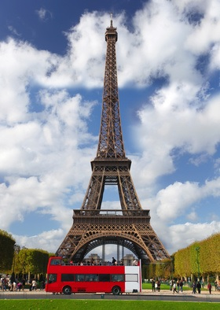 | Keep calm and go to PARIS!  Paris has some of the most beautiful and historical buildings and monuments in the world.  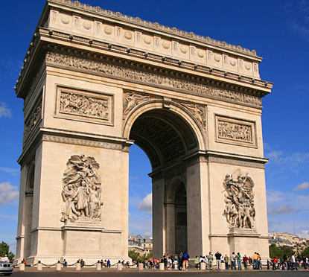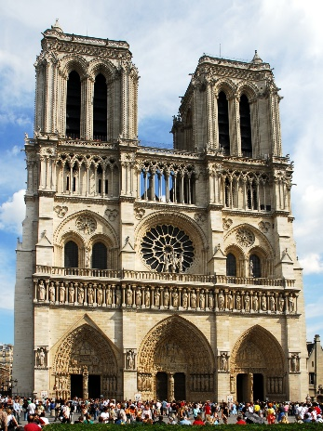  The Eiffel Tower is the most famous of all, and one of the most iconic constructions in the World. Dare to ride the lift to the top and view the city from heights of 300 metres!  The Arc de Triomphe is at the end of the Champs Elysees (shopping district) and forms the largest roundabout in Europe.  The Notre Dame Cathedral is the most visited attraction, which dates back to 1163.  Visit – www.thomascook.com for more information and book your city break today! | 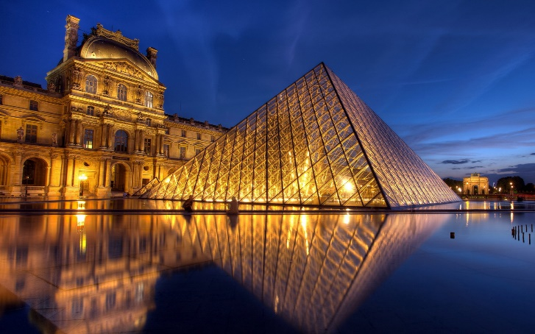  The Louvre Museum, which contains the famous Mona Lisa and many other works of art is the world’s largest museum. Plan your day here as there are over 380,000 objects and displays including 35,000 works of art!  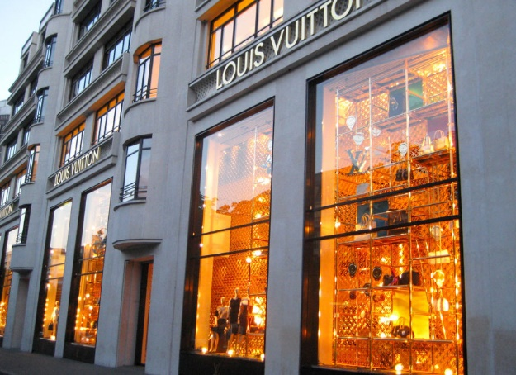  Once you have seen the sights and experienced the French cuisine treat yourself to some retail therapy and stroll along the Champs Elysees. Go for the sales though as the designer stores can be expensive and may only let you enter on invite basis only. During your weekend stay you must visit one of the annual fashion shows and catch a glimpse at the latest fashion trends on the catwalk.

