Maths Year 2
Statistics w/c 27.4.20
The objectives we are working on this week are:

- interpret and construct simple pictograms, tally charts, block diagrams and simple tables
- ask and answer simple questions by counting the number of objects in each category and sorting the categories by quantity
- ask and answer questions about totalling and comparing categorical data.

We will begin by making tally charts and pictograms as a systematic method of recording data. The children should already be able to count in 5s and understand the vocabulary of total, altogether, more, less and difference.
To understand how to construct tally charts, watch the following:
https://www.bbc.co.uk/bitesize/clips/z7r9jxs
Look at the following screen shot to help you understand what to do.
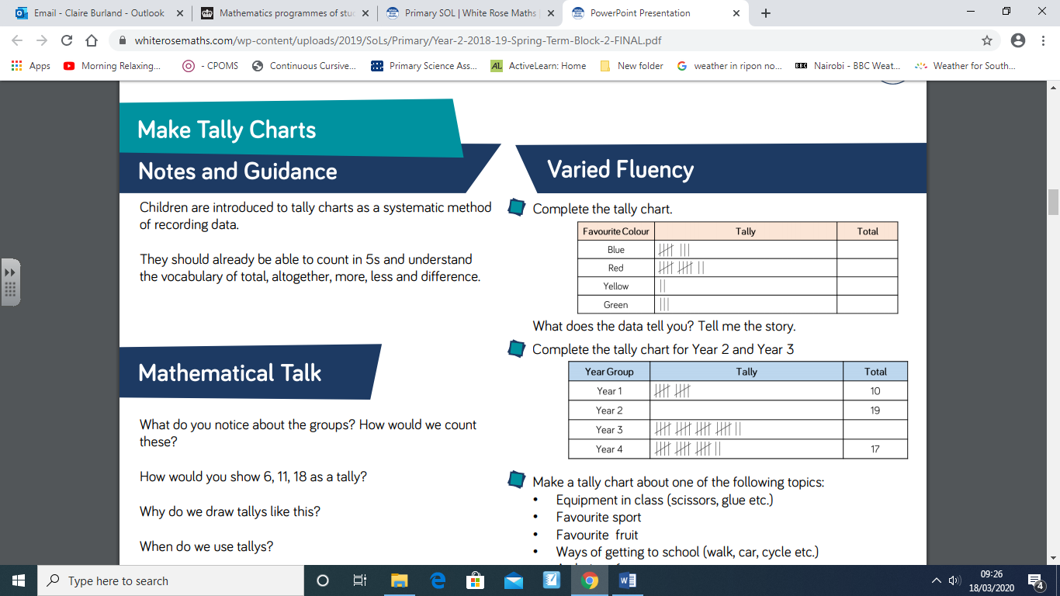

Look at the screen shot above and you will see that in the bottom chart 10 children are in Year 1 and 17 children are in Year 4. We can clearly see there are more children in Year 4. Often you will get a question which says ‘How many more children are in Year 4 than in Year 1?’ To answer this question, we need to count on from 10 up to 17 or to count back from 17 to 10 (which ever way you find easier). Hopefully you will get the answer ‘7.’ If you put a line of 10 cubes together and a line of 17 cubes together, you can see that the longer line has 7 more.

A pictogram is very similar to a tally chart. Look at the picture below to help you. In this example a blue circle equals 2 children. How many children do you think half a circle would equal?
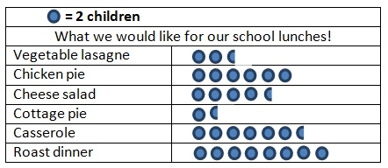

I have put some worksheets together where you have to fill in the tally charts and pictograms and answer questions about them. I have also included some problem-solving questions to stretch your learning!

Happy Learning!

Mrs Burland

