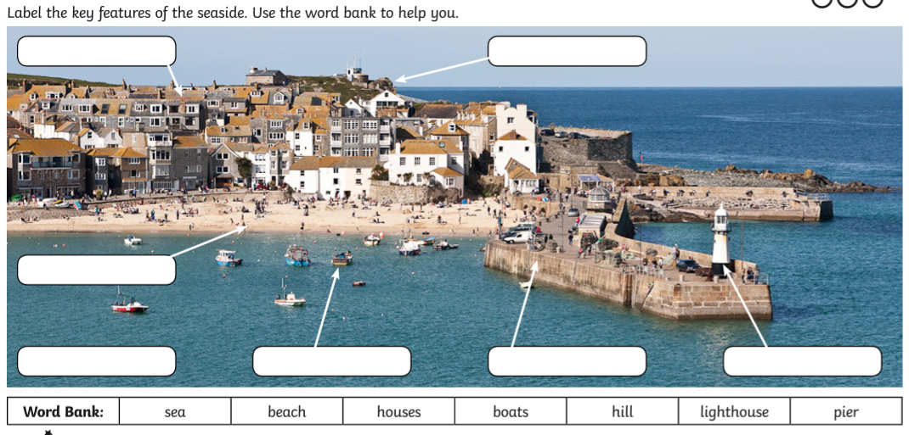
LO: To know the key features of a coastal town.

