Maths Year 6
Statistics w/c 30.3.20
The objective we are working on this week is:
- calculate and interpret the mean as an average.
We will learn about when the mean as an average is used, we will learn how to calculate the mean and we will practise the skill by finding the mean in a range of contexts.
To understand how to calculate and interpret mean as average, watch the following video and read the attached information:
https://www.youtube.com/watch?v=DZYhvMCFE5Q
https://www.youtube.com/watch?v=jvOT2dV3KwM

Also, look at the following screen shot to help you understand what to do. Children should be able to use the bus stop method for division, including answers which give rise decimal remainders.
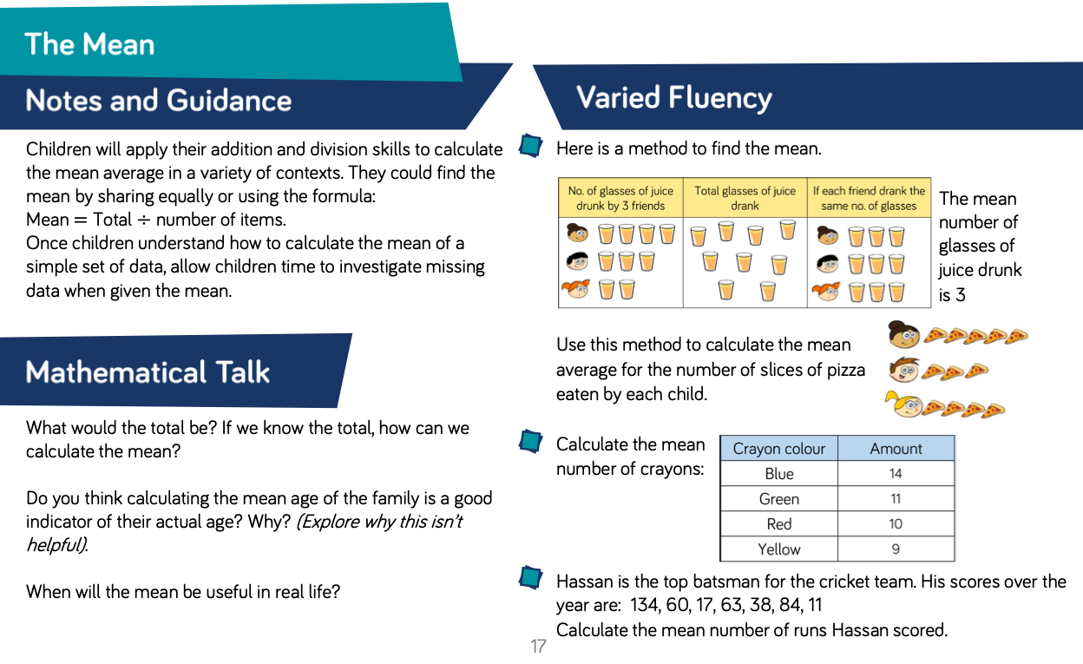

Look at the screen shot above. There is a table showing the amount of different coloured crayons. The question asks you to calculate the mean number of crayons. To do this, we need to find the total number of crayons first 14+ 11+ 10+ 9 = 48 Then we divide by how many amounts we added together (4) so, 48 divided by 4 = 12. The average is 12! We can use the bus stop method to help us divide if we need to.
Have a go at the next question above to practise… Remember to show your working!

I have put some more challenges together where you can practise finding the mean of a set of numbers – the Averages challenge!! I have also included some problem-solving questions to stretch your learning!
Happy Learning!
Miss Rogan

