Maths Year 4
Statistics w/c 30.3.20
The objectives we are working on this week are:
♣ to be able to interpret and present discrete and continuous data using appropriate graphical methods, including bar charts and time graphs.
♣to solve comparison, sum and difference problems using information presented in bar charts, pictograms, tables and other graphs
- We will continue looking at line graphs this week.

Look at the following screen shot to help you understand what to do.

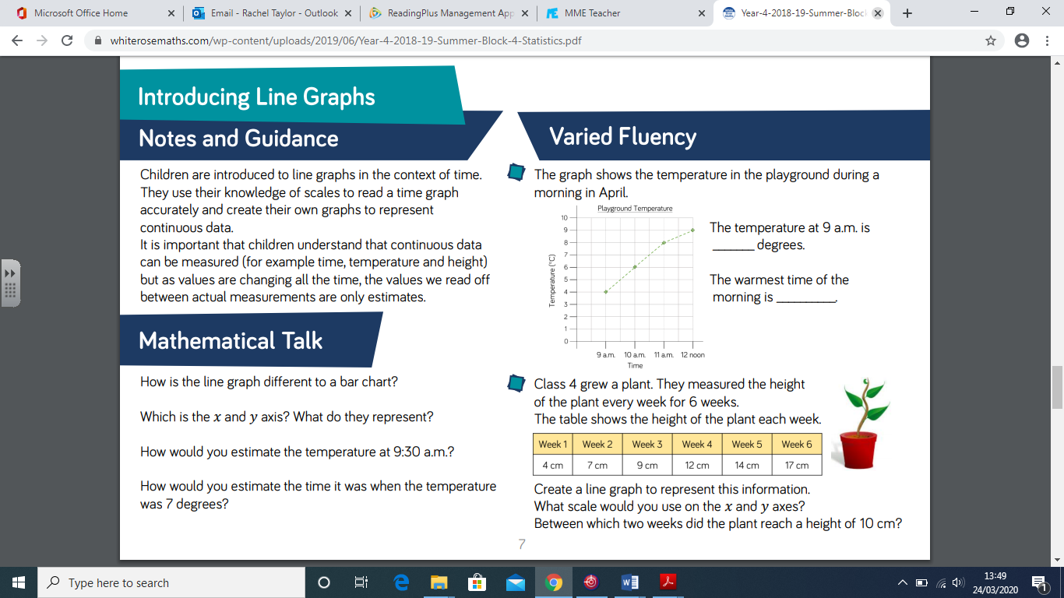

Look at the screen shot and you will see that the line graph is showing the temperature of a playground during the day. In order to answer the questions, the children will need to read the time of day (written along the bottom of the line graph) and then read the temperature (written vertically).

Look at this screen shot:
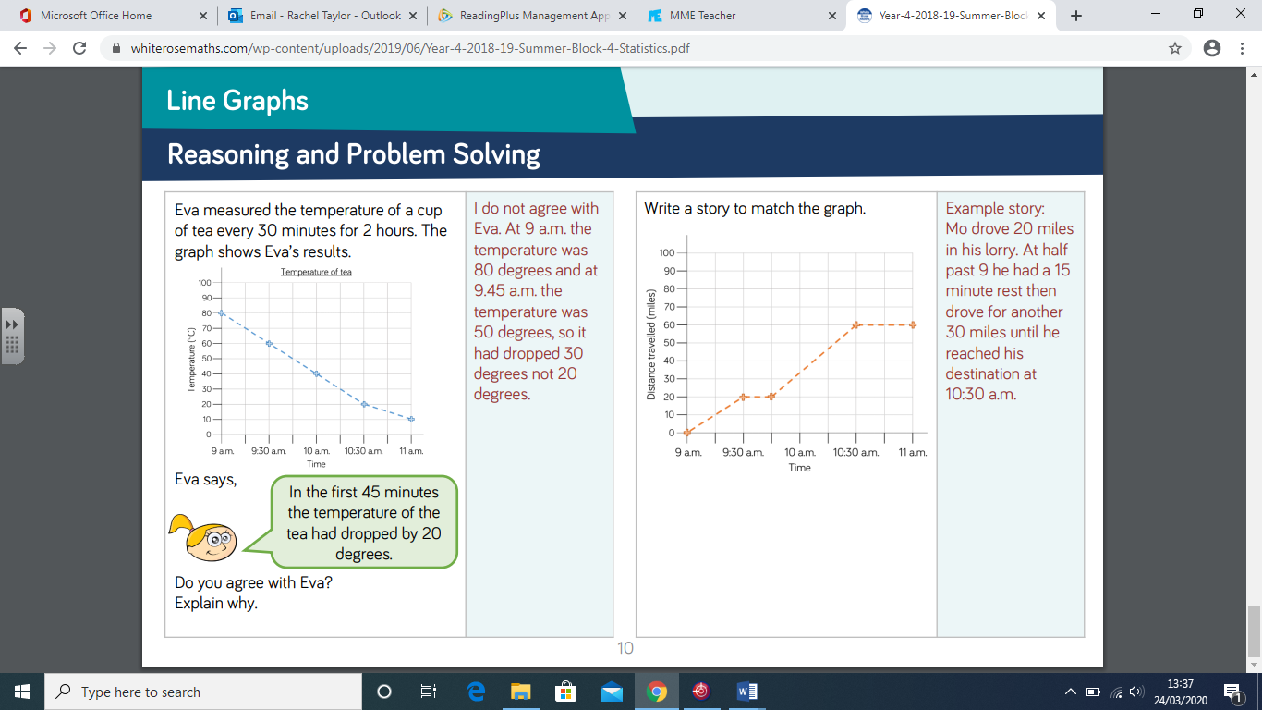

- The children have been presented with a line graph, for the first question, the children need to read Eva’s statement and say whether they agree or disagree with her. They need to be able to explain why.
For the second line graph, the children need to try and write a story of a journey writing about the distance covered in a given amount of time.

- Have a go at creating your own line graph based on this data:
Plant growth
Week 1 | Week 2 | Week 3 | Week 4 | Week 5 | Week 6
4cm | 7cm | 9cam | 12cm | 14cm | 17cm

I have put some worksheets together where you have to answer questions about line graphs and also some problems. On this sheet you will see a table of results which need presenting as a line graph please!

Enjoy!

Mrs Taylor

