Which materials have you chosen and why?

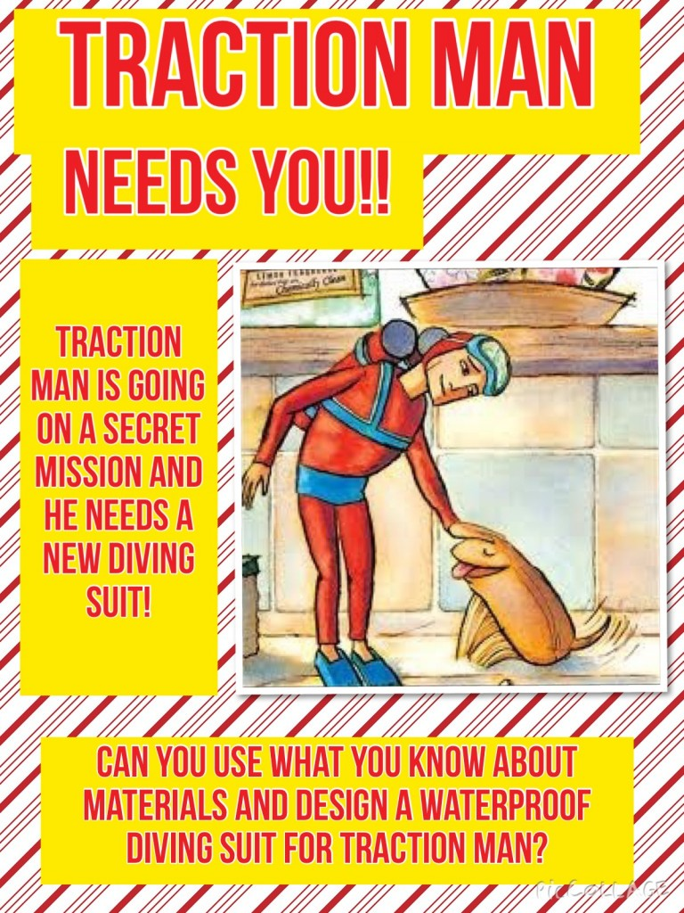

Draw and label a new diving suit for Traction Man