Maths Year 4
Shape w/c 20/04/2020
The objectives we are working on this week are:
compare and classify geometric shapes, including quadrilaterals and triangles, based on their properties and sizes
♣ identify acute and obtuse angles and compare and order angles up to two right angles by size
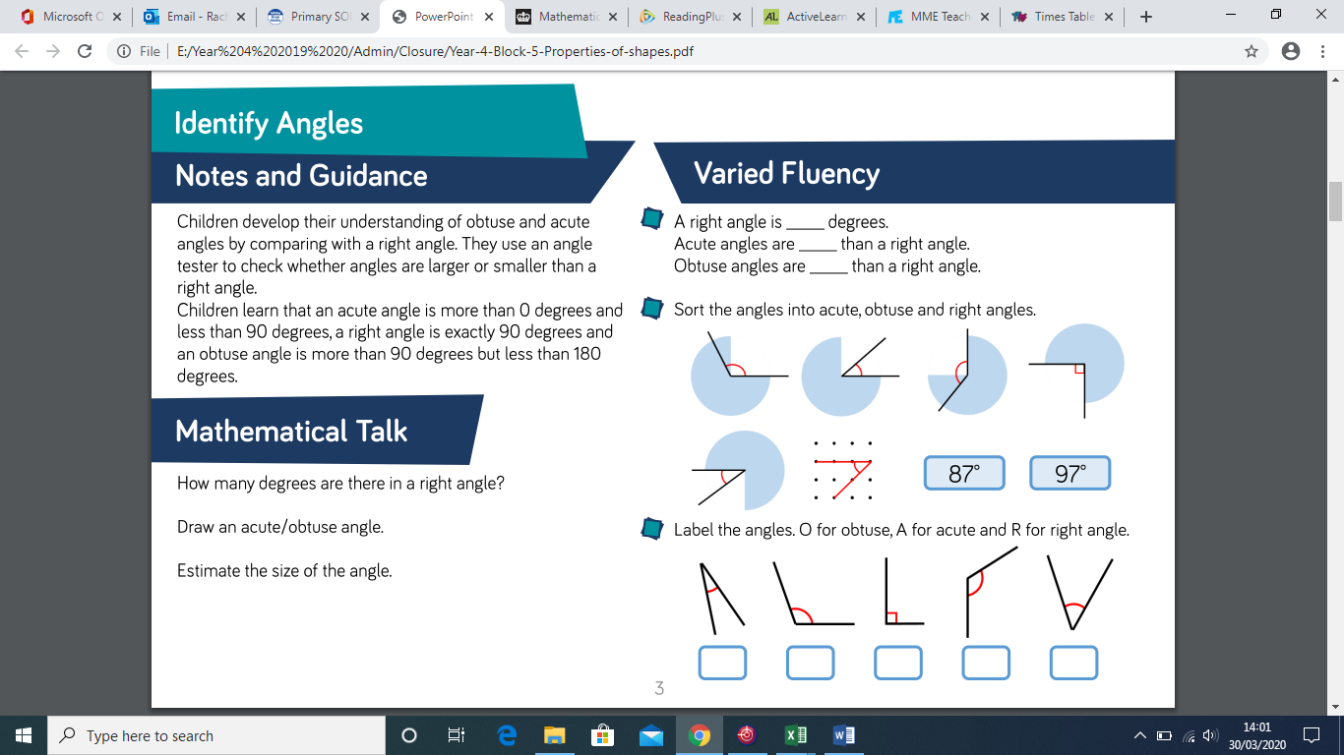

From looking at the screen shot, you will see there are the three types of angles which the children learn about in year 4 – a right angle (90º), an acute angle (less than 90 º) and an obtuse angle (more than 90 º).
Now watch the clip:
https://www.bbc.co.uk/bitesize/topics/zb6tyrd/articles/zg68k7h
- Having watched the clip, can the children find in your homes and gardens and items which contain right angles? (You can always photograph them doing this).
Now can they find any items with acute angles or obtuse angles in?

- Have a go at completing the sheet, by deciding whether an angle is acute, obtuse or a right angle!

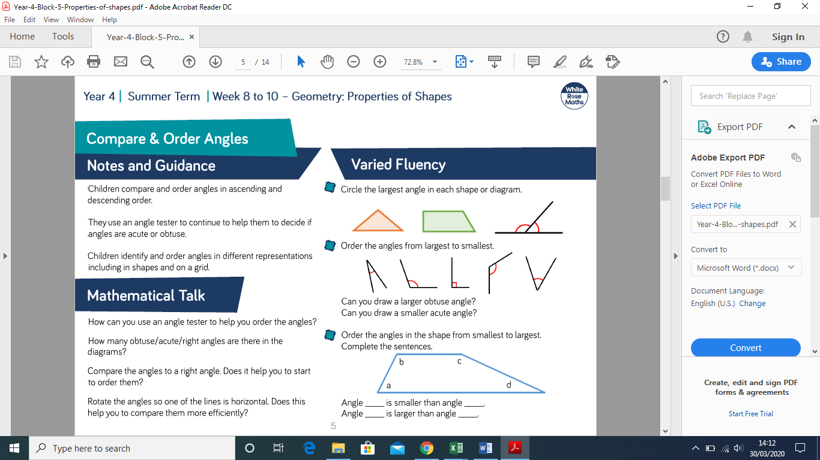

- Now that you can identify acute, obtuse and right angles, can you put them in order? Make sure when you are ordering the angles that you read the questions to ensure you are ordering in the correct order!!

- And to top off your maths learning this week, I have included some angles reasoning and problems solving for you – ENJOY!

Mrs Taylor

