Year 5 SPAG

This week can you complete the Year 5 Autumn Revision on Classroom Secrets

https://kids.classroomsecrets.co.uk/category/year-5/year-5-gps/

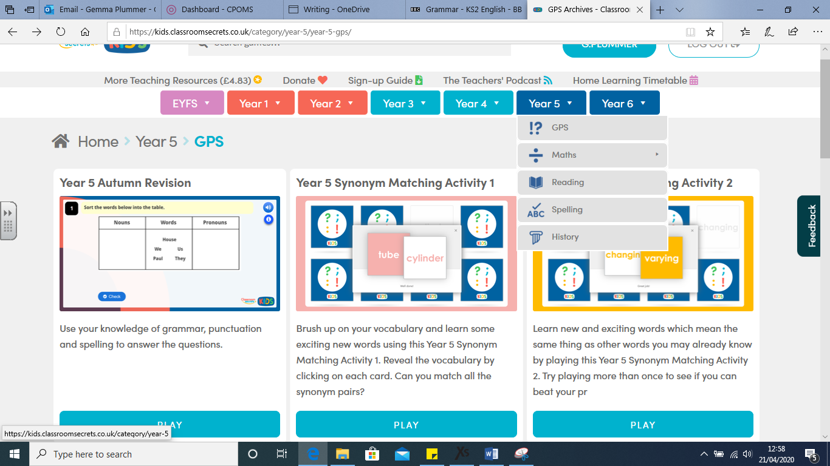

Go to Classroom Secrets, click on Year 5 and select GPS. The first section is called Year 5 Autumn Revision, click on that and have a go at the quiz.

Once you have done that have a go at some of the synonym activities.

