Multiplying and dividing by 10,100 and 1000 Y5 Answers
1)
a) 400
b) 750
c) 21000
d) 3300
e) 600

2)
a) 24
b) 6.8
c) 0.350
d) 0.9
e) 0.009
3)
- 1.5
- 60

1
Answer the following questions. You can use place value cards and counters to help you.

1. (a) 4 x 100 = 400

(b) 75 x 10 = 750

(c) 21 x 1000 = 21000

(d) 100 x 33 = 3300

(e) 60 x 10 = 600

2. (a) 2400 ÷ 100 = 24

(b) 68 ÷ 10 = 6.8

(c) 350 ÷ 1000 = 0.350

(d) 9 ÷ 10 = 0.9

(e) 9 ÷ 1000 = 0.009

3. Work out

(a) 15 x 10 ÷ 100 = 1.5

(b) 6 ÷ 100 x 1000 = 60
3. Fill in the missing numbers in these calculations.

(a) 6 ÷ 10 = 0.6

(b) 45 x 100 = 4500

(c) 0.74 = 74 ÷ 10

(d) 1000 x 658 = 65800

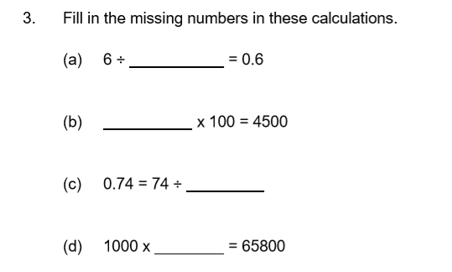
65.8
10
45
10

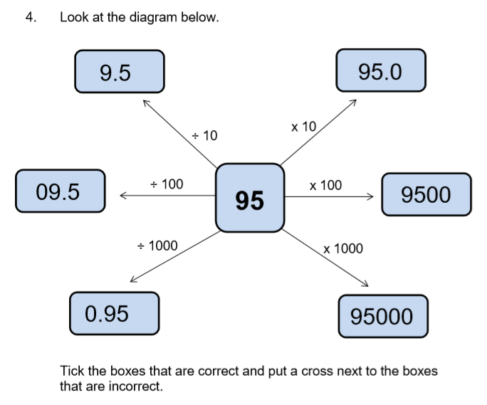
X

√

√

X

X

√

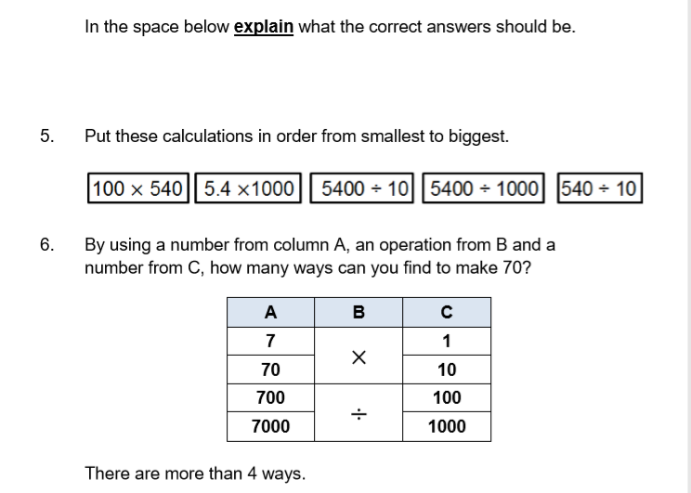
7 x 10 = 70
70 x 1 = 70
700 / 10 = 70
7000 / 100 = 70
5

4

3

2

1

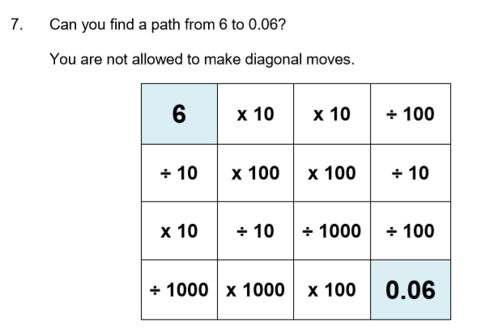

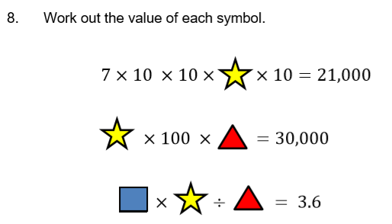
1.2
10
30
10
30
30

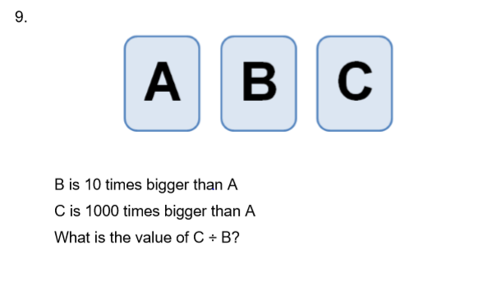
There are many different combinations that can be used to work this one out but c divided by b will always be 100. These are only a few examples.
If A = 10 B would = 100 and C would = 10000
So 10000/ 100 = 100
If A = 20 B would = 200 and C would = 20000
So 20000/200 = 100
If A= 3.5 B would = 35 C would =3500
So 3500 / 35 = 100

