Year 5 Explanation Writing Task

Your task is to write an explanation text on the life cycle of an amphibian, for a Year 3 child to read.

- Watch the video below on Life Cycles of Different Organisms. Take notes on the life cycle of a frog and metamorphosis.
https://www.bbc.co.uk/teach/class-clips-video/science-ks2--ks3-the-life-cycles-of-different-organisms/zvh8qp3

- Watch the Powerpoint presentation. It will tell you everything you need to know about writing an explanation text!

- Now look at the example explanation text. We are going to make ours much more interesting! Answer these questions below to help you decide what you need to include in your writing:
- How is the text presented? How is it structured and laid out?
- What do you notice about the language that is used?
- Can you find any language you could use in your own writing? For example, ‘First’ and ‘then’.
- Who is the target audience for this text? How do you know that?
- Does it give you enough information to be able to explain the life cycle of a frog?
- Which bits do you like/not like?
- What key words from our own learning could we include?

4. Once you have answered these questions, use the planning format and the pictures to help you plan your ideas. We need to make our explanation text much more interesting than the one we have just read! Decide what key vocabulary you could use from your learning to make it exciting. Did you record any when making notes from the video clip? Our explanation text is aimed at Year 3- they have already learnt the life cycle of a frog, but they didn’t learn about metamorphosis. How can you explain what this is? Remember to use notes from the video to help you.

- Use your plan to help you write your explanation text. Use your notes from watching the video to help you. You can present your explanation text in whatever layout you wish. Time to be really creative!

- Once you have finished, read through your writing carefully to check the following and edit if required.
- Spellings
- Punctuation – capital letters, full stops, commas, apostrophes, question marks and exclamation marks. What other punctuation have you included? Have you included it correctly?
- Does it make sense?
- Can you add anything else to improve it?
- Does it appeal to your target audience?

Gathering Content questions to help with your planning

How is the text presented? How is it structured and laid out?
________________________________________________________________________________________________________________________________________________________________________________________________________________________________________________________________________________________________________________________________________________________________________

What do you notice about the language that is used?
________________________________________________________________________________________________________________________________________________________________________________________________________________________________________________________________________________________________________________________________________________________________________

Can you find any informative language you could use in your own writing?
________________________________________________________________________________________________________________________________________________________________________________________________________________________________________________________________________________________________________________________________________________________________________

Who is the target audience? How do you know that?
________________________________________________________________________________________________________________________________________________________________________________________________________________________________________________________________________________________________________________________________________________________________________

Does it give you enough information to be able to fully explain the life cycle of a frog?
________________________________________________________________________________________________________________________________________________________________________________________________________________________________________________________________________________________________________________________________________________________________________

Which bits do you like/not like?
________________________________________________________________________________________________________________________________________________________________________________________________________________________________________________________________________________________________________________________________________________________________________

What key words from our learning could we include?

________________________________________________________________________________________________________________________________________________________________________________________________________________________________________________________________________________________________________________________________________________________________________
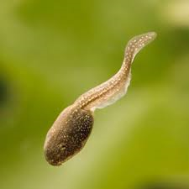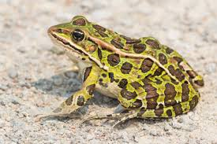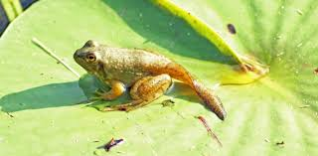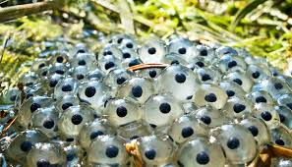

Title: ______________________________________________________________
Draw and label the life cycle of a frog. Make sure you show where metamorphosis happens. Provide an explanation of this means.

Websi

List facts about amphibians.

Can you find out some other examples of amphibians and research their life cycles?

Which words will you include to help you make your explanation text more interesting? Here are some examples…
Metamorphosis
Amphibian
Tadpole
Reproduction
Egg
Froglet
Remember to include pictures!

