Maths Year 5
Division w/c 30.3.20

The objectives we are working on this week are:
- divide numbers up to 4 digits by a one-digit number using the formal written method of short division and interpret remainders appropriately for the context.

Watch the links below to help you remember the method we use for division:
https://www.youtube.com/watch?v=IS-YRqkMxdg
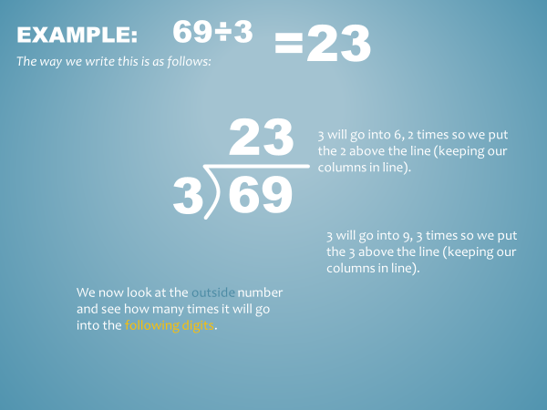
https://www.bbc.co.uk/bitesize/topics/z36tyrd/articles/zgxdfcw
Write these calculations in your home learning book and use the method above to solve the following:
1. 8,792 ÷ 7 =
2. 9,180 ÷ 6 =
3. 11,562 ÷ 3 =
4. 32,832 ÷ 9 =
5. 28,480 ÷ 8 =
6. 17,622 ÷ 3 =
7. 67,445 ÷ 7 =
8. 34,605 ÷ 5 =
9. 59,190 ÷ 6 =
10. 33,388 ÷ 4 =
1. 525 ÷ 5 =
2. 219 ÷ 3 =
3. 126 ÷ 2 =
4. 328 ÷ 4 =
5. 276 ÷ 3 =
6. 729 ÷ 9 =
7. 648 ÷ 8 =
8. 436 ÷ 4 =
9. 848 ÷ 8 =
10. 5455 ÷ 5 =
1. 472 ÷ 4 =
2. 968 ÷ 8 =
3. 904 ÷ 2 =
4. 765 ÷ 5 =
5. 895 ÷ 5 =
6. 8,792 ÷ 7 =
7. 9,180 ÷ 6 =
8. 11,562 ÷ 3 =
9. 32,832 ÷ 9 =
10. 28,480 ÷ 8 =
1. 315 ÷ 5 =
2. 288 ÷ 3 =
3. 684 ÷ 2 =
4. 528 ÷ 4 =
5. 717 ÷ 3 =
6. 472 ÷ 4 =
7. 968 ÷ 8 =
8. 904 ÷ 2 =
9. 765 ÷ 5 =
10. 895 ÷ 5 =

