Maths Year 5
Factors, multiples and prime numbers w/c 27.4.20

The objectives we are working on this week are:
- identify multiples and factors, including finding all factor pairs of a number, and common factors of two numbers.
- know and use the vocabulary of prime numbers, prime factors and composite (non-prime) numbers.
- establish whether a number up to 100 is prime and recall prime numbers up to 19.

Use the following link to re-cap on finding factors
https://www.bbc.co.uk/bitesize/topics/zfq7hyc/articles/zp6wfcw
https://www.theschoolrun.com/what-are-multiples-and-factors

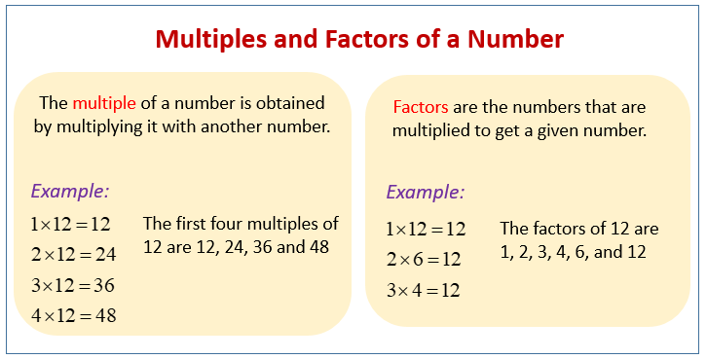

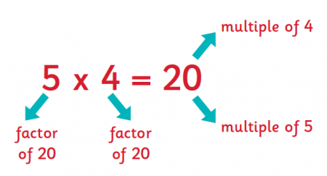

Now have a look at the following link to find out what a prime number is.
https://www.bbc.co.uk/bitesize/topics/zfq7hyc/articles/z2q26fr

Prime numbers
Prime numbers are special numbers that can only be divided by themselves and 1.
19 is a prime number. It can only be divided by 1 and 19.
9 is not a prime number. It can be divided by 3 as well as 1 and 9.
The prime numbers below 20 are: 2, 3, 5, 7, 11, 13, 17, 19.
Don't forget: the number 1 is not thought of as a prime number.

Then complete as many tasks as you can in your home learning book.

