Year 3 Recommended Reads

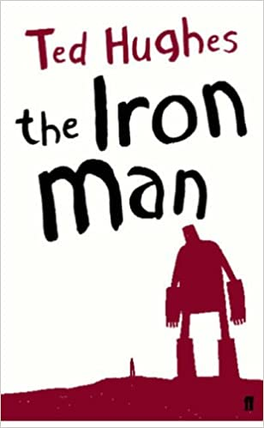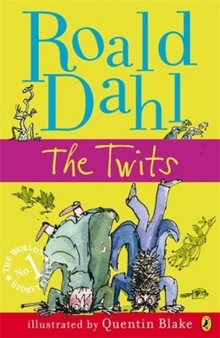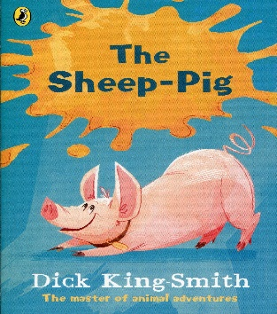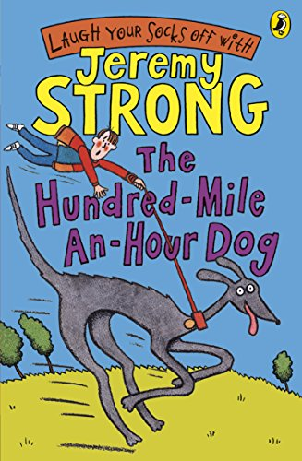
Books for Readers at Greater Depth (3S)
The Iron Man by Ted Hughes.
The Sheep-pig by Dick King-Smith.
The Abominables by Eva Ibbotson.
The Lion, the Witch and the Wardrobe by CS Lewis
Hansel and Gretel by Anthony Browne.

Books for Readers Working at National Expectation.(3B and 3W)
The Battle of Bubble and Squeak by Philippa Pearce.
Cat Tales: Ice Cat by Linda Newberry.
Charlie and the Chocolate Factory by Roald Dahl.
Esio Trot by Roald Dahl.
The Twits by Roald Dahl.
James and the Giant Peach by Roald Dahl.
The BFG by Roald Dahl.
Hodgeheg by Dick King-Smith.
The Sandman and the Turtles by Michael Morpurgo
The Hundred Mile an Hour Dog by Jeremy Strong.

