Year 2 STATISTICS PRACTICE – Task 1: Tally Charts
Starter: Can you name these charts and diagrams?
Which is a Pictogram, Tally Chart and Block Diagram?
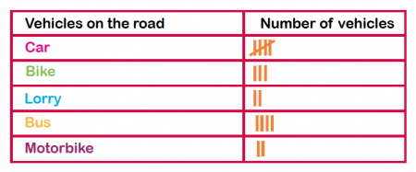
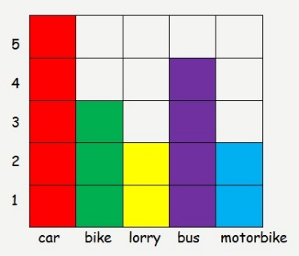
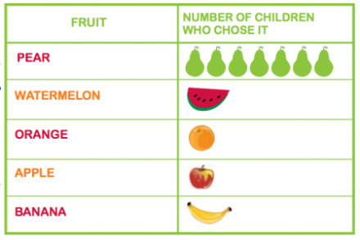

_____________________________
_____________________________
_____________________________

Favourite Colour | Tally | Total
Green
Pink |  | 14
Blue
Orange |  | 17
Purple |  | 9
Yellow |  | 20
This Tally Chart is unfinished. Can you complete it?

Which is the most popular colour?
_____________________________
_____________________________
Which is the least popular colour?

How many more people chose orange over blue?
_____________________________

What else does the Tally Chart show you?

Year 2 STATISTICS PRACTICE – Task 1: Tally Charts
Carefully read the text below. Then read it again, highlighting the key information and numbers. Complete the Tally Chart to show the information you have read.

James asked everyone in his class what their favourite sport was. Ten people chose football and three people chose rugby. Bella and Katy chose dance and eight people said tennis. James’ favourite sport is cricket.

Title – What was James finding out?

 | Tally | Total

What does the data in your Tally Chart show you?
______________________________________________
______________________________________________
______________________________________________
______________________________________________
Year 2 STATISTICS PRACTICE – Task 2: PICTOGRAMS
Look carefully at the Pictograms below and answer the questions.
Key: = 1

Five apples were sold on Sunday. Complete the Pictogram to show this.
How many apples were sold on Friday? ________________
What was the total amount of apples sold on Monday and Tuesday? ________________
The shop sold the most apples on _______________________.
The least amount of apples were sold on _____________________.
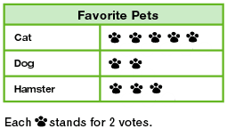

Which pet got the most votes? _____________
Which pet got the smallest amount of votes? ________________
How many people chose cats as their favourite pet? _______
_______ people voted for Hamsters.
Year 2 STATISTICS PRACTICE – Task 2: PICTOGRAMS
Create a Pictogram using the Tally chart below.
Easter Eggs eaten | Tally | Total
Monday |  | 7
Tuesday |  | 10
Wednesday |  | 5
Thursday |  | 3
Friday |  | 4

Pictogram:
Day | Easter Eggs Eaten
Monday
Tuesday

Wednesday

Thursday

Friday

Key: = 1

What was the total amount of Easter Eggs eaten on Monday, Tuesday and Thursday?

Number Sentence: _____ + ______ + _______ = _______
Year 2 STATISTICS PRACTICE – Task 3: Block Diagrams
Look carefully at the Block Diagrams below and fill in the gaps in the sentences.
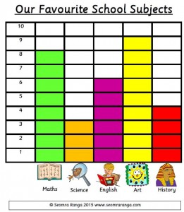

The most popular subject was _____________because it got _______ votes.
The least popular subject is __________________ as it has _______ votes.
Eight people voted for ___________________.
Four people voted for _____________________.
The subject that got 6 votes was _____________________.

Class _____ collected the least house points.

Class ____ have the most house points.

Class 5 have got _____ fewer house points than Class 2.
Year 2 STATISTICS PRACTICE – Task 3: Block Diagrams
Create a Block Diagram using the Tally Chart below.
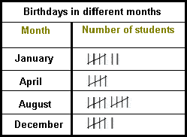

A Block Diagraph to show Birthdays in different months
Year 2 STATISTICS PRACTICE- TABLET FRIENDLY GAMES

All games can be found on the Topmarks website: https://www.topmarks.co.uk/maths-games/5-7-years/data-handling

Block Diagrams/Bar Chart Practice:
https://mathsframe.co.uk/en/resources/resource/51/bar_charts

Pictogram Practice:
http://toytheater.com/fishing/
http://toytheater.com/fruit-fall/
https://www.softschools.com/math/data_analysis/pictograph/games/

Tally Chart Practice:
https://www.softschools.com/math/data_analysis/tally_chart/

Interpreting Data on Block Diagrams, Pictograms and Tally Charts:
http://flash.topmarks.co.uk/4771

