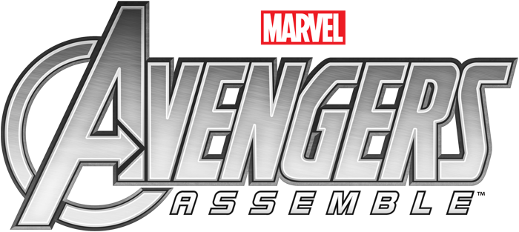
VERAGES
One day, Iron Man and the Hulk are arguing over which of the avengers is truly the greatest; so they decide to collect some data.
In this booklet you’ll find information about all the Avengers. It’s your task to find the mean for each skill; any avenger who has a HIGHER score for that skill than the average should get a medal.

 | Strength | Cunning | Speed | Trickery | Intellect
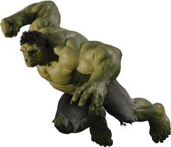  The Hulk | 10 | 3 | 5 | 3 | 7
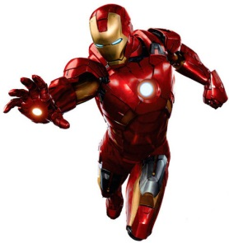  Iron Man | 8.5 | 8 | 10 | 9 | 10
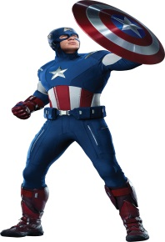Captain America | 9.5 | 5 | 9.5 | 5 | 6
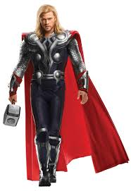  Thor | 9.5 | 6 | 9 | 8 | 5
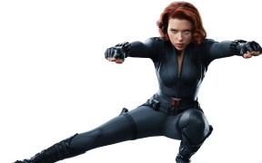  Black Widow | 8 | 10 | 7 | 9.5 | 9.5
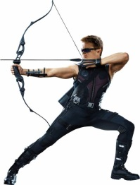  Hawkeye | 6 | 3 | 7 | 8.5 | 6
Mean of Strength
Working Out Box

Answer:____

Mean of Cunning
Working Out Box

Answer:____

Mean of Speed
Working Out Box

Answer:____

Mean of Trickery
Working Out Box

Answer:____

Mean of Intellect
Working Out Box

Answer:____

Medal Table
Colour in a medal of the avenger gets one for that skill
 | Strength | Cunning | Speed | Trickery | Intellect
The Hulk
Iron Man
Captain America
Thor
Black Widow
Hawkeye

