Mrs Plummer’s Year 5 Recommended Reads

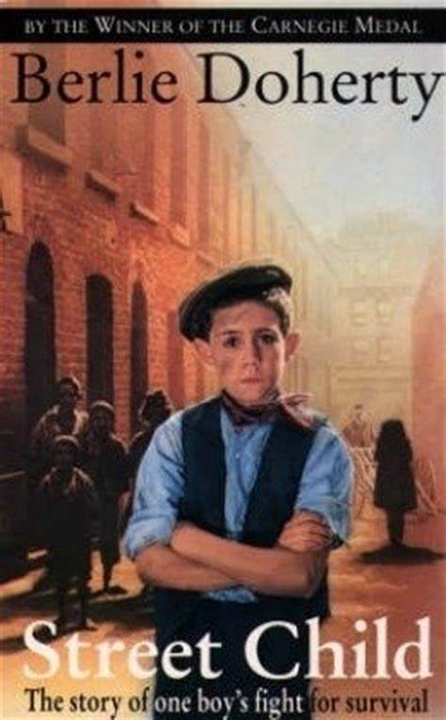
Goodnight Mr Tom by Michelle Magorian
Street Child by Berlie Doherty
Tom’s Midnight Garden by Phillippa Pearce
Mr Stink by David Walliams
The Parent Agency by David Baddiel
Room 13 by Robert Swindells
Skellig by David Almond
Five have Plenty of Fun by Enid Blyton
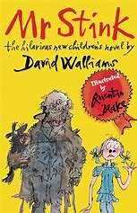
Harry Potter and the Philosopher’s Stone

Towards Greater Depth
Wolf Brother by Michelle Paver
Waiting for Anya by Michael Morpurgo
Little Women by Louisa May Alcott
Alice in Wonderland by Lewis Carroll
Clockwork by Philip Pullman

