Miss Rogan’s Year 6 Recommended Reads
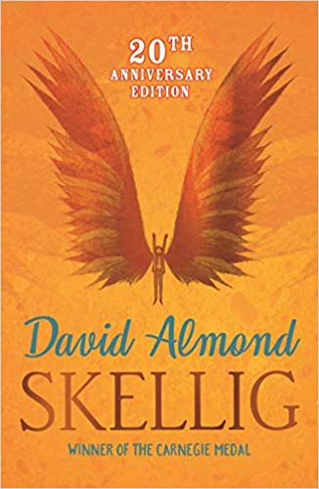
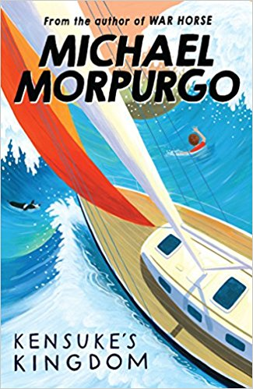
Skellig – David Almond
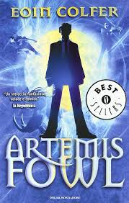
Kensuke’s Kingdom – Michael Morpurgo
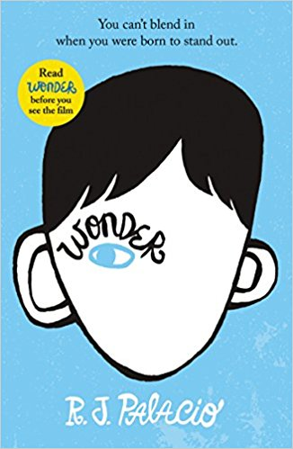
Wonder – R J Palacio
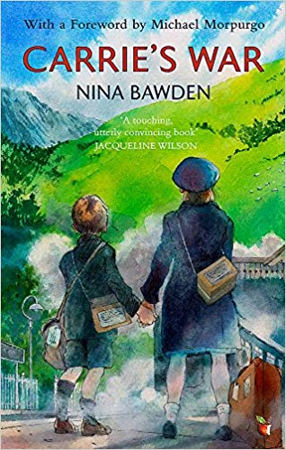
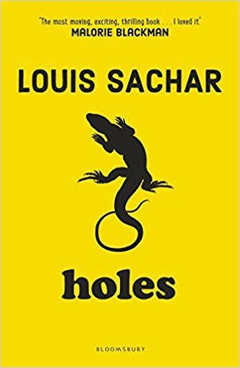
Holes – Louis Sachar

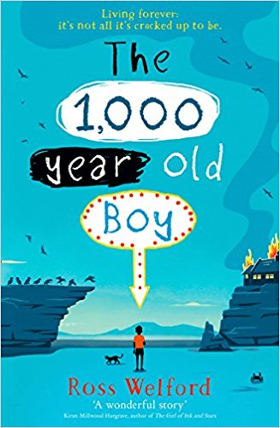
The 1,000 Year Old Boy – Ross Welford

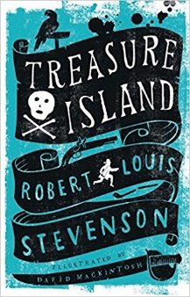
Treasure Island – Robert Louis Stevenson
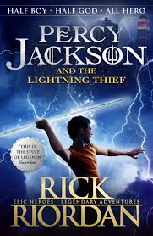
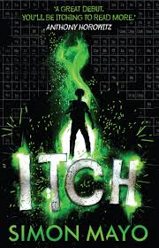
Artemis Fowl - Eoin Colfer
ITCH - Simon Mayo
Carrrie’s War – Nina Bawden

Percy Jackson and the Lightning Thief- Rick Riordan
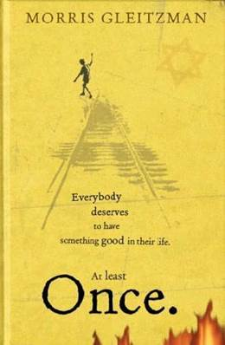
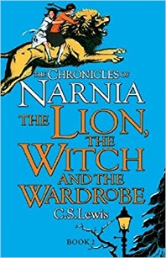
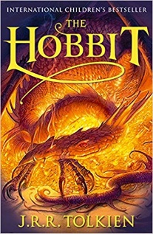
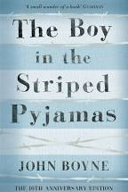
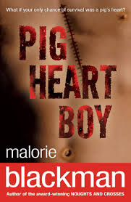
Towards Greater Depth

Hobbit – J.R.R. Tolkien

Chronicles of Narnia; The Lion The Witch and The Wardrobe – C.S. Lewis

Pig Heart Boy – Malorie Blackman

The boy in the striped pajamas - John Boyne

Once - Morris Gleitzman

