Triangles Challenge

1)
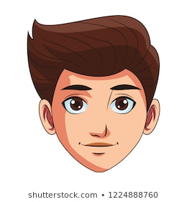

This is Simon
Simon has said “If I use 6 straws to make a triangle, I can only make an equilateral triangle.” Investigate whether Simon is correct or not. Prove your answer!

2) Use this line and draw two more sides to create:

- An equilateral triangle
- A scalene triangle
- An isosceles triangle

Which triangle was the easiest to create? Which was the most difficult?

Quadrilateral Challenge

 | 4 equal sides | 2 pairs of equal sides | 1 pair of parallel sides
4 right angles
No right angles

Complete each of the boxes with a different type of quadrilateral. Which box cannot be completed? Explain why.

