How to make a revolting sandwich

Ingredients: Equipment you will need:
- 2 slices of brown bread – with the crusts on! | - 1 butter knife  - 1 sharp knife
- Squirty cream | - 1 plate

- Tomato Ketchup

- ½ an apple

- 1 slice of cheese

Method
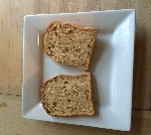 | - First, place two slices of bread on the plate.
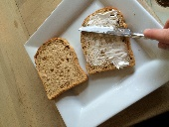 | - Next, squirt the cream onto one slice of bread and spread everywhere.
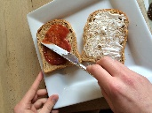 | - Spread tomato ketchup on the other slice of bread.
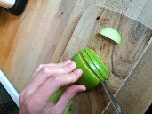 | - Chop apple into thin strips.
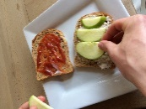 | - Place the apple on top of the cream.
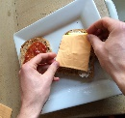 | - Cover the apple with a slice of cheese
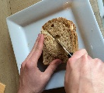 | - Finally, put the slices of bread together and cut the sandwich in half using a knife.

