

How to draw a line graph

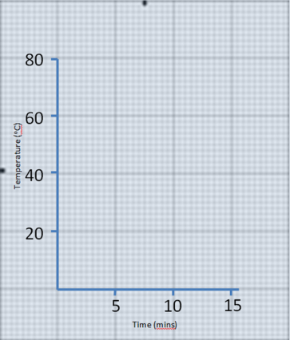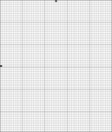

Step three – plotting the results:

1. Remember your scale – e.g. one little square means 2 units
2. Count up the y axis until you get to the number you want.
3. Put a ruler above the number, making sure it is straight. Leave the ruler there
4. Now, find the number you need on the x axis.
5. Follow the line of the graph paper up (without drawing a line) until you reach the ruler
6. Mark the place where the line meets the ruler with a little dot
7. Take the ruler away and draw a cross over the dot. Make sure your cross is very accurate!

Step Two – drawing the axis:

1. Find the highest value for the y axis (vertical)
2. Round the number up
3. Now you need to think of a good scale for the numbers.

First try 1 little square = 1 units in your results table

Then try 1 little square = 2 units in your results table

Next try 1 little square = 10 units in your results

1. Draw your y axis. Please make sure you have an equal gap between numbers

**REMEMBER you don’t have to write every number – you can go up in 5s or 10s**

1. Now repeat 1 – 4 for the x axis

Time (mins)

Temperature (oC)

15

10

5

20

80

60

40

Decide what is going to go on each axis.

If you’re not sure – brain, buddy, book, boss!

Step One – finding the start:

1. Look for the first big line up from the bottom of the graph paper
2. Look for the first big line across from the left
3. Mark a dot where the two big lines meet

This is where your axis start from – it’s called **the origin**

**Axis:**

Y axis = vertical

X axis = horizontal

**Variables:**

Y axis = dependent

X axis = independent

You will need:

* A sharp pencil
* A ruler
* A rubber

**x**

**independent**

**y**

**dependent**