Year 1 Home Learning for WC 30.3.20
Maths – Focus on Weight and capacity. Click on the following link to the White Rose Maths website. There is a video linked to our learning on fractions, one for each day. Each video comes with a set of questions which can be completed each day. Record the answers in your home
https://whiterosemaths.com/homelearning/year-1/
Play the measure activities on Maths City 2 – Purple Mash.
Play https://pbskids.org/peg/games/happy-camel
Play the Bingo game on Abacus

Reading – Complete a Reading Eggs lesson. Read your reading book to someone at home and share your thoughts. Complete a book review for one of the books that you have read.
Complete an Easter comprehension and an Easter word search.
Read the Easter comprehension and answer the questions.
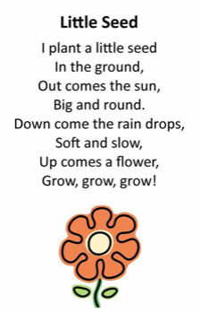
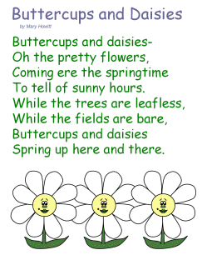

Writing – Read the poems about flowers.
Find a flower outside in your garden or a picture of a flower on the internet.
1 Write down some words that you could use to describe the flowers (some of these will be adjectives). Think about how the look, smell and where they grow.
2 Use these words to write a poem about the flower.
3 Re-read your poem lots of time – can you change it to make it better?
4 Practise reading your poem aloud and add some actions.
5 perform your poem to your family!
Finally, complete the handwriting sheet; try to join all of the letters.

Phonics
Day 1 – alternative pronunciations for ‘ey’.
Read the ‘ey’ comic on phonics play then make a list of the words with the different sounds that ‘ey’ makes.
Write a sentence with the words in.
http://phonicsplaycomics.co.uk/comics.html
Day 2 – alternative spelling for the /s/ phoneme
https://www.youtube.com/watch?v=zVbLPt1caQI
Watch the clip and write down the different ways of spelling the /s/ sound. Can you find any other words to fit in each category?
Day 3 – Play Dragon’s Den (Phonics Play – free activities)
https://www.phonicsplay.co.uk/DragonsDen.html
Practise the split digraphs i-e, o-e, a-e, u-e, e-e
Day 4 – Complete the sentence substitution activities (Phonics Play – free activities)
https://www.phonicsplay.co.uk/SentSubPhase5a.html
Day 5 – Phase 3 revision
Listen and read the /ai/ words then play the game (BBC bitesize).
https://www.bbc.co.uk/bitesize/topics/zvq9bdm/articles/z4xsxyc
Write down the /ai/ words and use them in sentences – remember to use capital letters and full stops for each sentence.

Extra fun ideas
Check out this website, it’s full of cool educational videos for children. https://thekidshouldseethis.com/

