Year 1 Home Learning for WC 27-4-20

Maths – White Rose Maths Home Learning – Summer term week 1 tasks
https://whiterosemaths.com/homelearning/year-1/
Focus on doubling (revision), grouping, sharing, finding half (revision) and
Click on the link to the White Rose Maths website. Each day, there is a video to watch first and then a task to complete. Record the answers in your home learning book and then get an adult to check them.
Play Topmarks Hit the Button – x2, x5, x10, doubles and halves to 20.
https://www.topmarks.co.uk/maths-games/hit-the-button
Play ‘Beetle Bump’ on Abacus.
Play ‘Sand Search’ on Abacus.
Play ‘Counting in 2s’ on Classroom Secrets Kids – Year 1
Play ‘Number Names Game Flash Cards’ on Classroom Secrets Kids – Year 1

Reading – Complete Reading Eggs tasks. Read some books at home or online and share your thoughts. Complete a book review for one of the books that you have read. It is also lovely to listen to adults read books so remember to listen to the Bedtime Stories on the school website.
Read the and complete the comprehension about the Seaside.

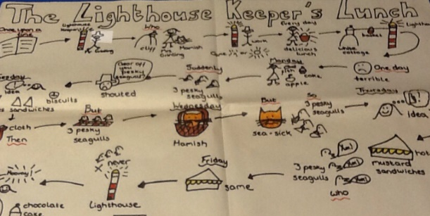
Writing – Link to GEOGRAPHY – The Seaside
Task 1 – Listen to and / or read the story of ‘The Lighthouse Keeper’s Lunch’.
https://www.youtube.com/watch?v=GqzEj_W4bUk
Create a story map of the events in the correct order.

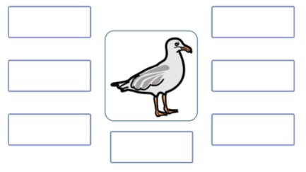
Task 2 – Write a word bank of words to describe
the pesky seagulls.

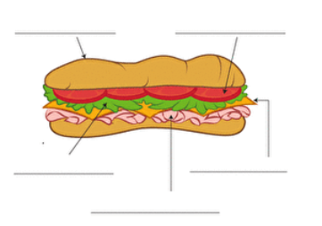
Task 3 – The seagulls only like tasty sandwiches. You are going to design a disgusting sandwich that will keep the seagulls away!
Draw and label a sandwich with a disgusting sandwich – what fillings will
make it really disgusting?
Task 4 – Look at the example instructions for making a disgusting sandwich. Write your own set of instructions to make your sandwich.
Remember to include a list of ingredients and equipment.
Task 5 – Complete some of the activities on the Home Learning sheet.

SPAG (Spelling, Punctuation And Grammar)
Classroom Secrets – GPS section – Play game ‘Question or Not a Question’.
BBC bitesize Small Town Superheroes - punctuation – Play game to identify where capital letters should be.
https://www.bbc.co.uk/games/embed/small-town-superheroes?exitGameUrl=http%3A%2F%2Fbbc.co.uk%2Fbitesize%2Farticles%2Fzncgvk7

Phonics
Day 1 – alternative pronunciation for ‘i’ (revision)
http://phonicsplaycomics.co.uk/comic_ph5b_a_kind_fish.html
Read the ‘i’ comic ‘A Kind of Fish’ on phonics play comics. Make a list of the words with the different sounds that ‘i’ makes.
Day 2 – alternative pronunciations for ‘or’
Watch Geraldine Giraffe ‘au’. Make a list of the words that she finds and then practise reading them.
https://www.youtube.com/watch?v=dOHDkQGhku4
Watch Geraldine Giraffe ‘aw’. Make a list of the words that she finds and then practise reading them.
https://www.youtube.com/watch?v=7xvdbR6g060
Day 3 – alternative pronunciations for ‘or’
Use the words that you collected yesterday to write interesting sentences – can you add some adjectives?
One sunny morning in August, I saw a large ginger cat yawning and scratching a tree with its sharp claws.
Day 4 – ‘aw’ pronounced ‘or’ - saw
Phonics Play – free activities Username: march20 Password: home
https://new.phonicsplay.co.uk/resources/phase/5/sentences-5a
Read the sentences using the ‘aw’ words
Day 5 – or as in sort
Play the ‘or’ game on Forest Phonics. Listen to the word and then choose the correct spelling.
https://www.bbc.co.uk/bitesize/topics/zd63xyc/articles/zdp4pg8

Science - Our science topic for this term is Materials. The challenge mat is full of exciting activities linked to the topic. I’ve also included our ‘Five Finger Facts’. These tell us what we need to be able to understand by the end of the topic.

Well-being activity
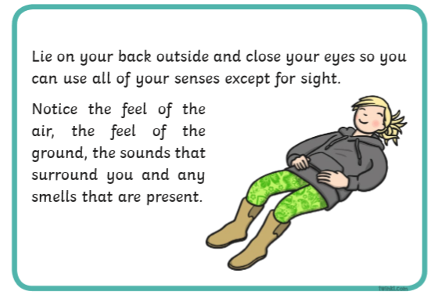

Happy Learning!
Miss Ryder

Mindfulness at Moorside.
“Mindfulness is one strategy that can reduce stress. Mindfulness is a way of being. Practicing mindfulness means paying attention to what's happening in the moment and accepting those experiences and feelings without judgment.”
In your Learning Pack this week, we have given you two activities that you can do by yourself or with your family. Follow the instructions carefully on the cards and allow yourself time to really focus on the activity.
It would be great to have photographs of what you have been doing for your Mindfulness. If you can, please send them into school. Thank you.

