Year 1 and 2 Science Home Learning Challenges 20.4.30
Our new topic will be
MATERIALS
Identifying different materials  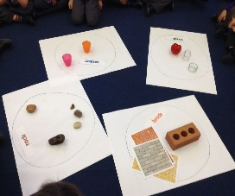  Have a look around your house and garden. What things can you find made from wood, plastic, glass, water, rock?  How will you record what you have found? You could make a table or a bar chart, take photos or drawings. Which material was the most/least popular? Why do you think this? | Comparing and grouping materials  Look at all the different materials you collected in the previous activity (Identifying different materials), think about how you can compare and group them. You might want to use the following words to help you:  Hard, soft, stretchy, stiff, shiny, dull, rough, smooth, bendy, absorbent, waterproof, transparent, opaque.  Can you group them in a different way? | Which materials do we use?  Watch the following BBC clip (which material do we use?)  https://www.bbc.co.uk/bitesize/topics/zrssgk7/articles/z9pgcdm  Think about why glass is a good material for a window and cotton is a good material for our clothes. What would happen if windows were made from cardboard or our clothes were made from rocks?  Can you invent a silly object? Eg, a chocolate kettle, a glass football or a metal book. Why is your invention silly?
Design a waterproof outfit  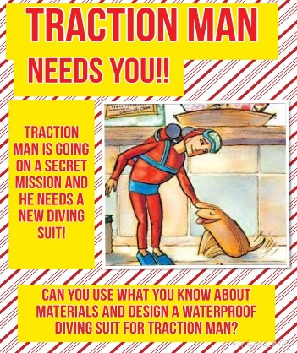  Watch the story of Traction Man on You Tube.  Your task is to design a new diving suit for Traction Man. You can put your design on to the attached piece of paper if you wish.  https://www.youtube.com/watch?v=6FfW3X1V4J0 | Choose the best materials to build a new house  Read the story of The Three Little Pigs. There are lots of versions on You Tube. We like https://www.youtube.com/watch?v=cRSX5s2J3WY  Think about why the first two houses fell down and what materials these pigs could have used instead.  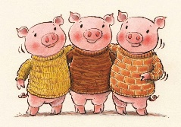  Using different materials at home, your task is to make a new house that won’t fall down. What materials did you use and why? Take a photo of your house or video yourself trying to blow it down! | Five Finger Facts  - I can identify and name a variety of everyday materials, including wood, plastic, glass, metal, water, and rock.  - I can describe what wood, plastic, glass, metal and rock feel like (using words like bumpy, soft, cold, transparent).  - I can group different materials, using words like soft, flexible, hard, squashy, waterproof, dull, shiny.  - I know why glass, wood, plastic, brick or paper would be used for certain jobs.  - I know (and can name) materials can be squashed, twisted or bent according to need.

