Year 1 and 2 Home Learning Challenges WC 27.4.20
Geography - The Seaside
Take a virtual tour of Whitby  Have you ever been to Whitby?  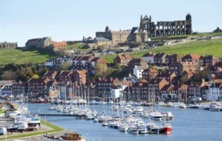  Follow the link to look around the main most popular sites in Whitby.  http://www.vrwhitby.co.uk/ | Comparing Whitby and Ripon  Using the virtual tour of Whitby and your knowledge of Ripon, complete the comparisons sheet to compare Ripon and Whitby.  Try to use some of this key vocabulary;  - physical features: beach, cliff, coast, forest, hill, mountain, sea, ocean, river, season and weather  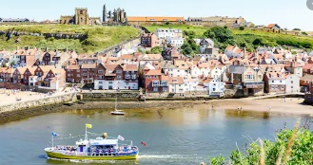  - human features: city, town, village, factory, farm, house, office, port, harbour and shop  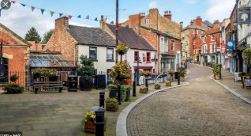 | Write a postcard home.  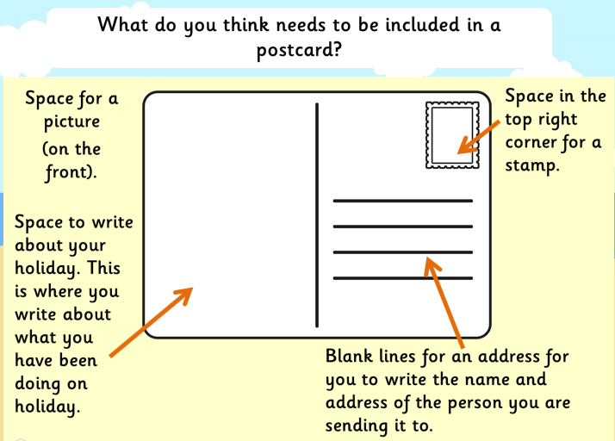  Why might people visit Ripon or Whitby for a holiday?  Imagine that you have been on holiday to Whitby and to Ripon. Write a postcard from each place to describe all of the exciting things that you have done.
Label the seaside features  1 Use the picture to label the seaside features.  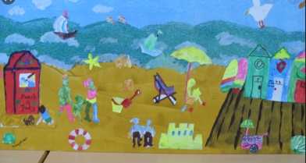  2 Draw your own picture of the seaside and label the human and physical features that you include.  Try to use some of this key vocabulary;  - physical features: beach, cliff, coast, sea, ocean, river  - human features: city, town, village, house, port, harbour, lighthouse and shop | 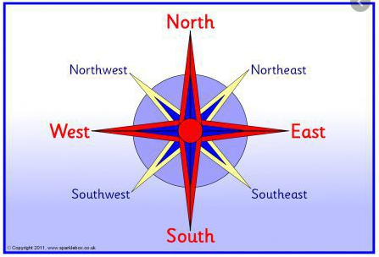  Compass Points  Complete the activities using compass points.  Directions game  1 Hide a toy somewhere in your house or garden.  2 Give instructions to someone so that they can find the hidden toy.  3 You must only use North, South, East or West to direct the seeker to the toy.  4 Swap roles and have another game. | 5 Finger Facts  See if you can learn these top 5 facts as part of the topic.  - human features – means anything created by people eg buildings.  - physical features – something that is formed naturally eg river, cliff  - I can name a physical and a human feature of Ripon and Whitby.  - The 4 main compass points are North, South, East and West  - Whitby is surrounded by the North Sea.

LO: To compare the physical and human features of Whitby and Ripon
Ripon
Whitby

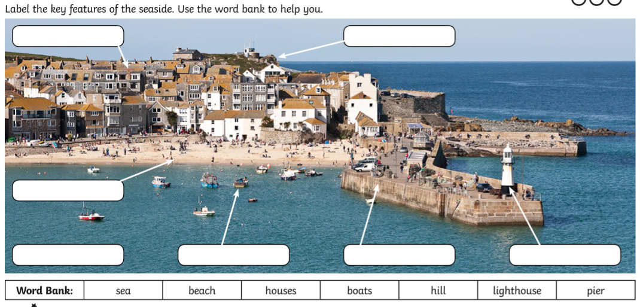
LO: To know the key features of a coastal town.

LO: To use geographical language to write a postcard.
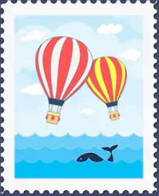
Dear

