Year 5 and 6 Home Learning Challenges
Geography  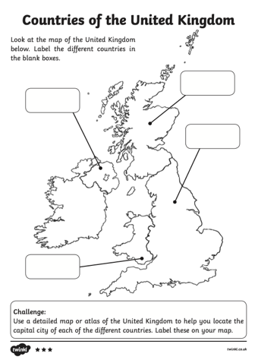  Have a go at the United Kingdom labelling challenge. Can you label each country and their capital city? Can you label Ripon? Can you label any other places you have visited in the UK using the atlas page to help you? | 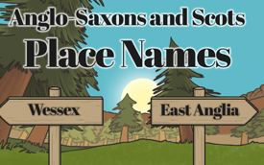  History  Create a poster to share your knowledge about Anglo-Saxon place names and their meanings. Use the information in your pack to help you. You could also do some more research of your own. Your poster should include examples of place names and their meanings, examples of Anglo-Saxon words/information related to the naming of places and pictures and diagrams to show places and/or their geographical location (where in Britain they are) | Science  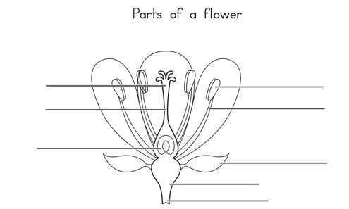  Read through the notes to help you understand the parts of a flower then draw and label the parts of a flower. Use the vocabulary cards and definitions to help you.
Art  A view from a window.  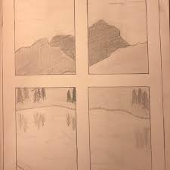  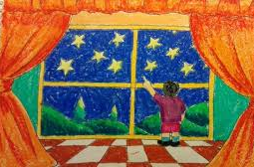  Look out of one of your windows and re-create what you see. You could sketch, paint or collage to create your artwork. | RE  Create a timeline of events in Easter story. For each event, include a detailed description and some pictures  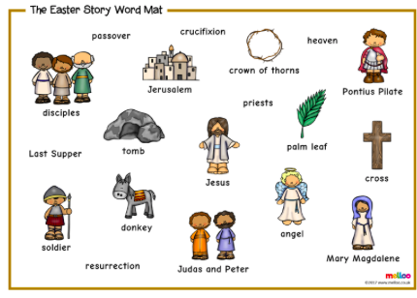 | PHSCE/DT  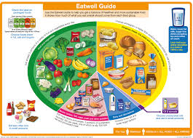  Using your understanding of a healthy balanced diet and the Eatwell guide, plan a weekly menu for your family using the menu plan to help you. Have a look for a recipe to you could cook with parents to feed your family at home. Take some pictures and let us know how you did using the food evaluation form.

