Year 1 and 2 Home Learning Challenges 30.2.30
Geography  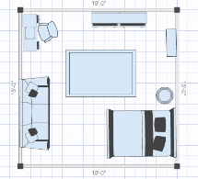  Imagine you are a bird sat on the ceiling in the favourite room in your house, looking down. What can you see? Where is the door? Where is the window? What furniture can you see? Create a bird’s eye map of your favourite room. | History  Look online to find out about Captain Robert Scott. What interesting facts can you find? Create a fact file about his life and expedition to the South Pole. Don’t forget you can include pictures as well.  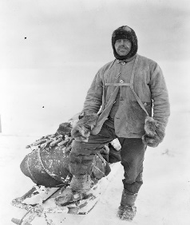 | Science  Spring has started and it is a beautiful time of year!  Make a list of spring flowers and draw a picture of each one.  How many of these did you think of? https://schoolgardening.rhs.org.uk/Resources/  SpotterGuide/Spring-flower-spotter
Art  Find some different leaves in your garden and using pencils or crayons can you make some leaf rubbings?  What different patterns can you make?  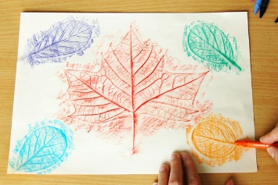 | RE  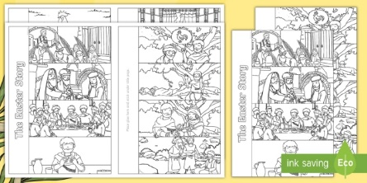  Using the Easter story you wrote last week, create a flap book using the attached sheet. | Metacognition  Use resources in your home to make a den/tent which you can read a book in. Which materials did you use to build your tent?  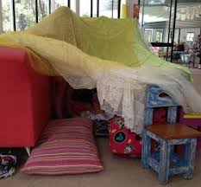  Find a torch and read a story in your den.

