Home Learning Challenges for Year 3!
Geography  Create a birds eye view of your house. You might need 2 drawings as you have an upstairs and downstairs.  The picture will help.  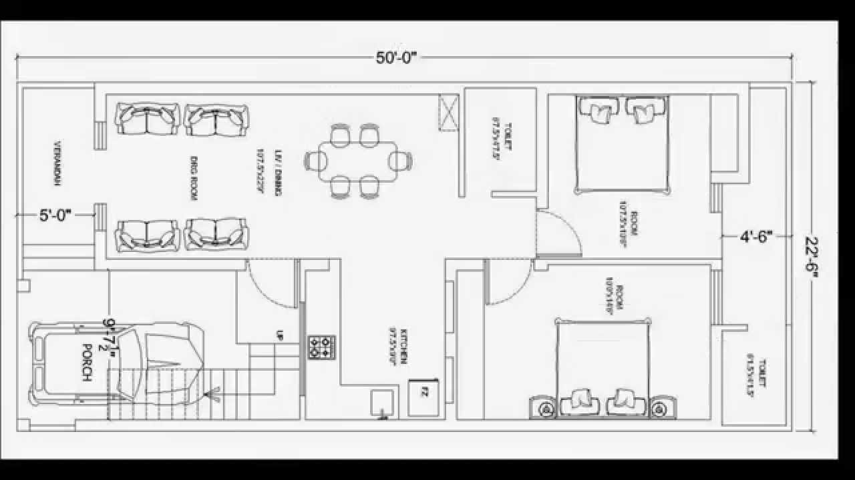 | History  Write a diary for one week about what you have done each day. What was the weather like? Did you go somewhere?  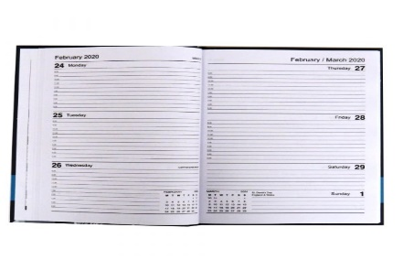  (use the writing template to help you) | Science – Materials  Design and make a parachute that you fly. For an extra challenge, make an egg holder so that your egg is protected when it lands.  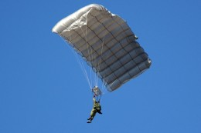
DT  Have a go at the recipes in your pack. If you are able to make some, take photographs and re-write the recipe, adding any additional steps you included. Or top tips. For examples, ‘Don’t forget to wash your hands. Or add some sprinkles for extra decoration. | Music.  Create a song/rap about Easter and how it makes you feel. You could record this and send it into school. Think of all the things you would have at Easter time. | RE  Have a go at researching how Easter is celebrated around the world. Follow this link from Newsround for some ideas.  https://www.bbc.co.uk/newsround/27093835  There’s also a powerpoint with some ideas too! Record your learning in any way you like:  a poster? Writing? Creating your own PowerPoint? Get creative!

