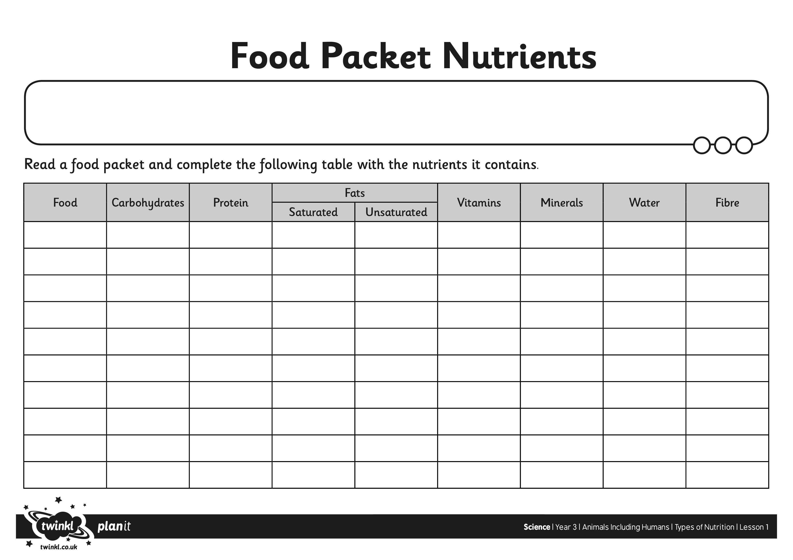

I can state why animals including humans need the right type of nutrients.