The cake is split into _____ equal parts.
Each part is worth one ___________.
This is the same as

Shade a ¼ of each shape.
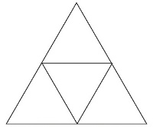

Circle the shapes that have a quarter shaded.
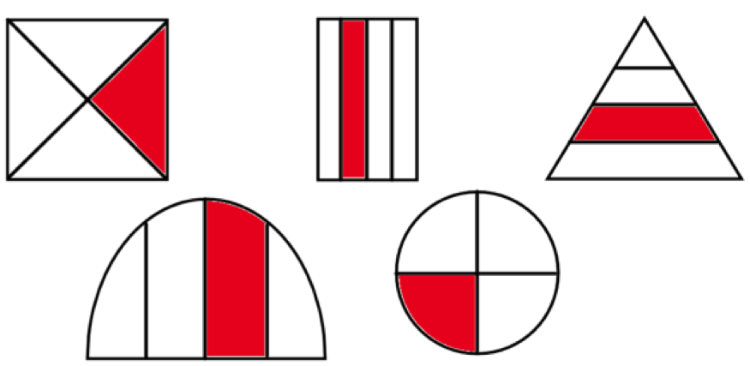

Which shapes do not have a quarter shaded. How do you know?
__________________________________________________________________________

Amy is folding two identical paper strips.
She says, “I think ¼ of the strip will be bigger than ½ of the strip because 4 is bigger than 2.”
Use paper strips to prove Amy is incorrect.
Explain your answer.

True or false?
¼ of the shape is shaded.
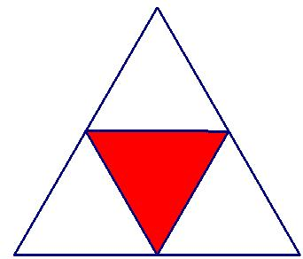
Explain your answer.

