Maths Year 6
Statistics w/c 23.3.20
The objective we are working on this week is:

- interpret pie charts and line graphs and use these to solve problems
We will begin by learning how to read pie charts to understand what they show us. The children should have some existing knowledge about pie charts from creating their own on World Book Day to show Year Six’s favourite book genres.
To understand how to interpret pie charts, watch the following:
https://www.youtube.com/watch?v=Ruc9n6ho3l4
Look at the following screen shot to help you understand what to do. Children should also have some understanding of percentages and be able to apply their understanding to help them interpret pie charts. Example:
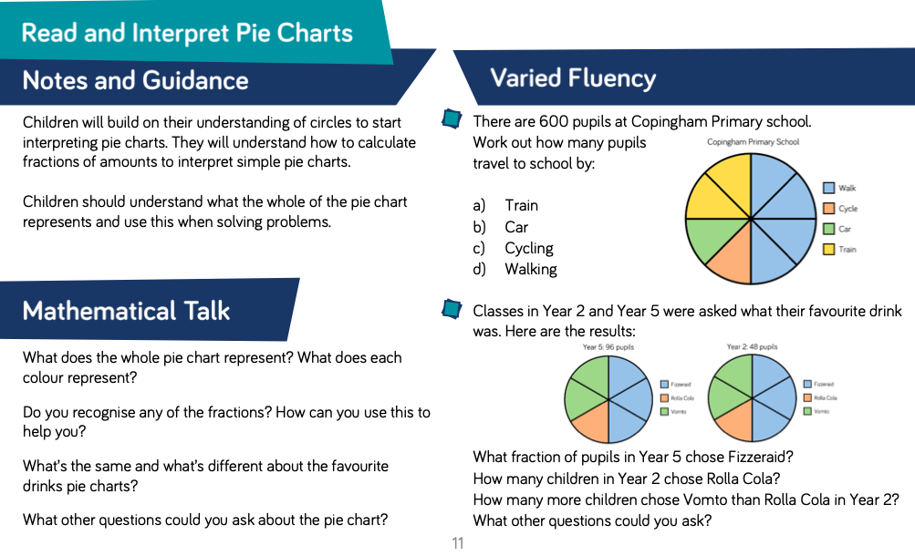
25%= ¼ 50% = ½ 75% = ¾ 20% = 1/5

Look at the screen shot above. You can see in the first pie chart that it is divided equally into 8 equal parts. There are 600 pupils in total so to find out how many pupils each equal section represents, we must divide 600 by 8, which is 75. We can then use the key to work out how many children travel by train, car, cycle or walk. There is only one section each representing cycling and cars, means mean 75 pupils travel to school by car and 75 travel to school by cycling. Two equal sections represent the train, therefore 75 x 2 = 150, which means 150 pupils travel to school by train. Four sections represent walking, therefore 75 x 4 = 300, which means 300 pupils travel to school by walking. We can also see that half the pie chart is blue (half of 600 is 300).
Line graphs are another way of representing data. Watch the following video to support you with understanding how to read and interpret line graphs.
https://www.youtube.com/watch?v=x9dfsti25HY
Have a look at the examples below to further help you understand how to read and interpret line graphs.
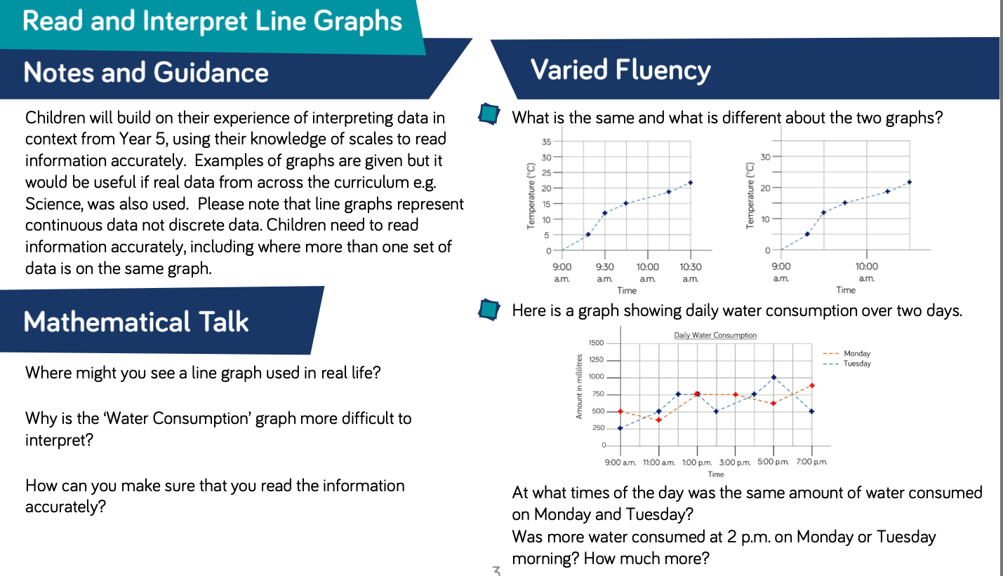

I have put some challenges together where you can practise reading and interpreting pie charts and line graphs. I have also included some problem-solving questions to stretch your learning!
Happy Learning!
Miss Rogan

