Maths Year 4
Statistics w/c 23.3.20
The objectives we are working on this week are:
♣ to be able to interpret and present discrete and continuous data using appropriate graphical methods, including bar charts and time graphs.
♣to solve comparison, sum and difference problems using information presented in bar charts, pictograms, tables and other graphs
- We will begin by looking at bar charts and answering questions about a bar chart. The children should already have an understanding of what bar charts are and how to read them carefully – making sure you look at the labels on each axis..
To understand how to interpret a bar chart, watch the following clip.
https://www.bbc.co.uk/bitesize/clips/z28jxnb

Look at the following screen shot to help you understand what to do.
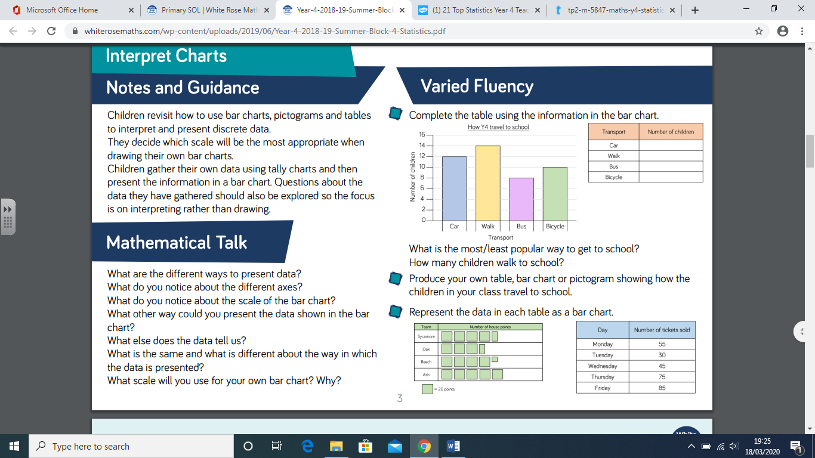

Look at the screen shot and you will see that the bar chart is about how the children in year 4 travel to school. In order to complete the table, the children will need to read which mode of transport is being used (written along the bottom of the bar chart) and then read the number of children which take that mode of transport (written vertically). When answering questions, the children need to understand what the words ‘popular’ and ‘average’ mean.

- In order to successfully create a bar chart, you need to make sure that your bars are the same width. You also need to make sure, when you are writing the numbers vertically up the page, they increase by the same number each time. Look at the bar chart success criteria!

- Problem solving – answer the questions based around the different bar charts and pictograms, read them carefully!

- Line graphs – Have a go at answering questions about a line graph. Make sure you read the questions carefully and you check the labels on both of the axes.

I have put some worksheets together where you have to answer questions about a bar charts and line graphs. There is also a sheet of data for you to present as a bar chart – make sure you use the bar chart success criteria!

Have fun!

Mrs Taylor

