Maths Year 3

Statistics w/c 23.3.20

**The objectives we are working on this week are:**

* Interpret and present data using bar charts, pictograms and tables.

The link below is a reminder about how to make tally charts and pictograms and is a good place to start and a recall of what you learned in Year 2.

Key vocabulary that you will use are: bar charts, pictograms, “How many more..?”

<https://www.bbc.co.uk/bitesize/clips/z7r9jxs>

Look at the following screen shot to help you understand what to do.

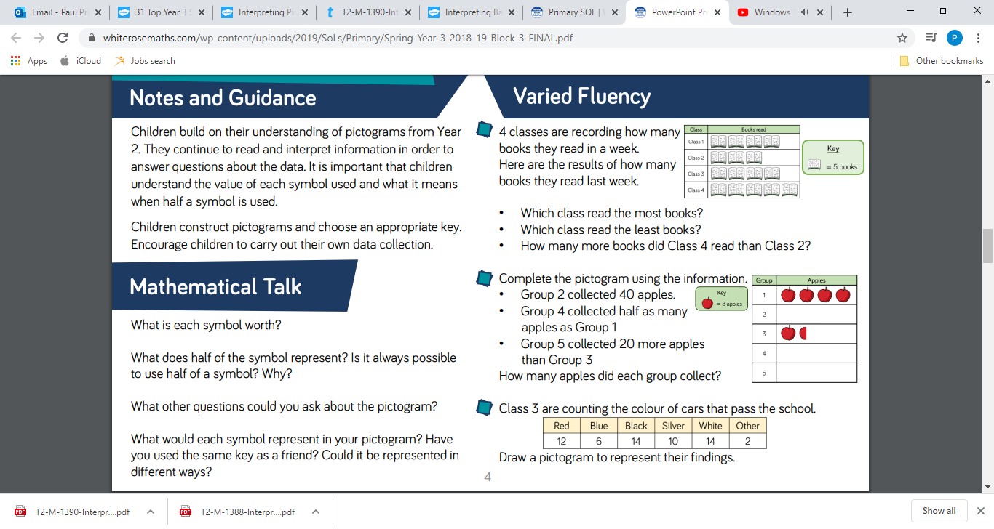

Look at the screen shot above and you will see that in the top chart there are 4 books and in Class 4 there are 5 books. The book has a value which can be seen in the “Key”.

Often you will get a question which says ‘How many more children read in class 1 than in class 2?’ To answer this question, we need to count how many books there are and remember to use the “Key” accurately.

A pictogram is very similar to a tally chart. Look at the picture below to help you. In this example a smartie equals 2 children. How many children do you think half a circle would equal?

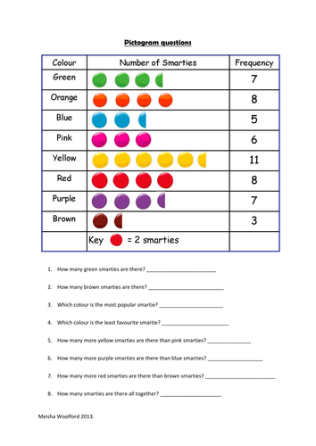

I have put some worksheets together where you have to fill in the tally charts and pictograms and answer questions about them. I have also included some problem solving questions to stretch your learning!

Happy Learning!

Mr Price.