Maths Year 2

Fractions w/c 23.3.20

**The objectives we are working on this week are:**

* Recognise, find, name and write fractions 1/ 2 , 1/ 3 , 1 /4 , 2 /4 and 3/ 4 of a length, shape, set of objects or quantity.
* Write simple fractions for example, 1 /2 of 6 = 3 and recognise the equivalence of 2/4 and ½.

Try to sing along with this song on You Tube <https://www.youtube.com/watch?v=DnFrOetuUKg>

(be careful, they sing fourths instead of quarters!)

Look at the following screen shot to help you understand what to do.

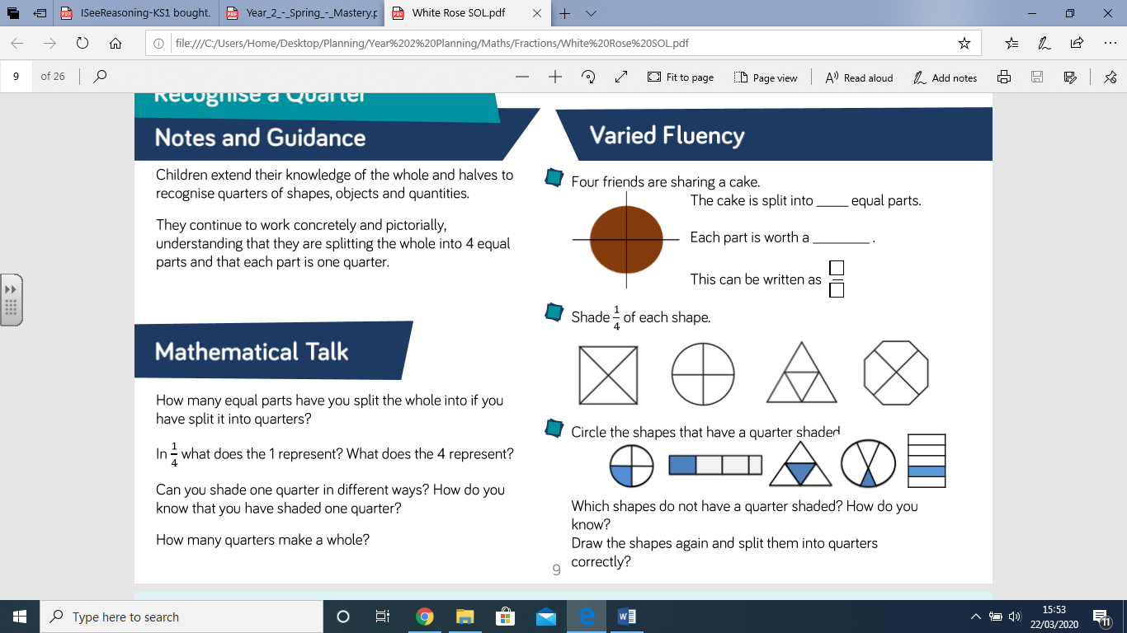

Look at the screen shot above and you will see that in the bottom chart 10 children are

Can you find some ‘bits of things’ at home? These could be pencils, coins, buttons, dried pieces of pasta, smarties, or even pieces of paper cut up small. Take a small handful, can you split them into 4 equal parts? Each part is a called quarter and is written as ¼. You could draw 4 circles (like we do in class) and put your ‘bits’ in each or draw dots in them.

Can you find ¼ of 8? Can you find ¼ of 16? Can you find ¼ of 20?

Complete the attached sheets finding halves and quarters.

I have also included some problem solving questions to stretch your learning!

Happy Learning!

Mrs Burland