Year 6 Writing Task
Persuade your reader to take their next holiday to the place where you live: Ripon.
- Look at the example advertisement to help you decide what you need to include in your advert:
- How is the text presented/structured/laid out?
- What do you notice about the language that is used?
- Can you highlight any persuasive language you could use in your own writing?

- Use the planning format and pictures to help you plan your ideas

- Use your plan to help you write your advertisement, ticking the parts of your plan as you include them, so you know you have included everything from your plan. (You can present your advert however you wish)

- Once you have finished, read through your writing carefully to check the following and edit if required.
* accurate spelling
* accurate punctuation
*does it make sense?
*can I add anything to improve it?

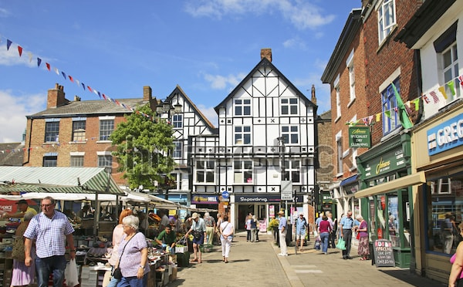
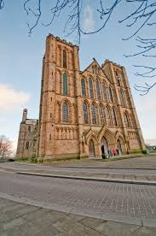
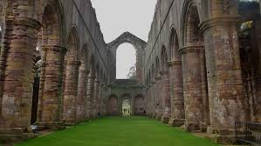

Gripping Title ______________________________________________________________
Which words will you include to help you persuade people to visit Ripon?
Remember to include pictures!
Describe another place in detail…

Describe another place in detail…

Website address:

Websi

List some of the great places to visit in Ripon using a range of adjectives to describe them…

Describe one the places from above in more detail and explain why it’s a great place to visit…

