Year 5 Persuasive Writing Task

Your task is to persuade your reader to take their next holiday in Ripon.

1. Look at the example advertisement for Orlando. Answer these questions to help you decide what you need to include in your advert.
- How is the text presented? How is it structured and laid out?
- What do you notice about the language that is used?
- Can you find any persuasive language you could use in your own writing?
- Who is the target audience? How do you know that?
- Does it persuade you to visit Orlando?
- Which bits do you like/not like?

2. Once you have answered these questions use the planning format and the pictures to help you plan your ideas. Decide who you are aiming the advert at? What would they like to see in Ripon? How would they see the advert, where would it be placed?

3. Use your plan to help you write your advert. As you include the parts of the plan tick them off so that you know you have included them all.
You can present your advert however you wish – Be Creative!

4. Once you have finished, read through your writing carefully to check the following and edit if required.
- Spellings
- Punctuation – capital letters, full stops, commas, apostrophes, question marks and exclamation marks. What other punctuation have you included? Have you included it correctly?
- Does it make sense?
- Can you add anything else to improve it?
- Does it appeal to your target audience?

Questions to help with your planning

How is the text presented? How is it structured and laid out?
________________________________________________________________________________________________________________________________________________________________________________________________________________________________________________________________________________________________________________________________________________________________________

What do you notice about the language that is used?
________________________________________________________________________________________________________________________________________________________________________________________________________________________________________________________________________________________________________________________________________________________________________

Can you find any persuasive language you could use in your own writing?
________________________________________________________________________________________________________________________________________________________________________________________________________________________________________________________________________________________________________________________________________________________________________

Who is the target audience? How do you know that?
________________________________________________________________________________________________________________________________________________________________________________________________________________________________________________________________________________________________________________________________________________________________________

Does it persuade you to visit Orlando?
________________________________________________________________________________________________________________________________________________________________________________________________________________________________________________________________________________________________________________________________________________________________________

Which bits do you like/not like?
________________________________________________________________________________________________________________________________________________________________________________________________________________________________________________________________________________________________________________________________________________________________________

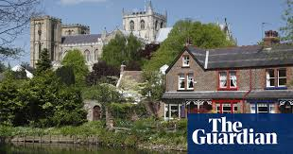
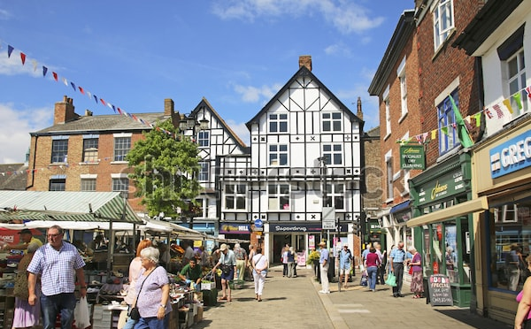
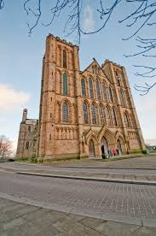
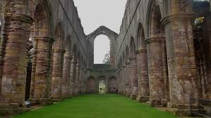
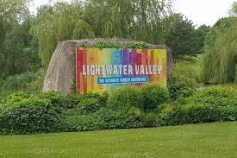

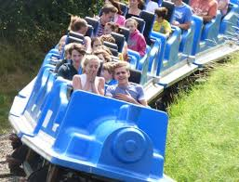

Gripping Title ______________________________________________________________
Which words will you include to help you persuade people to visit Ripon?
Remember to include pictures!
Describe another place in detail…

Describe another place in detail…

Website address:

Websi

List some of the great places to visit in Ripon using a range of adjectives to describe them…

Describe one the places from above in more detail and explain why it’s a great place to visit…

