Maths Year 5
Statistics w/c 23.3.20

The objectives we are working on this week are:
- Solve comparison, sum and difference problems using information presented in a line graph.
- Complete, read and interpret information in tables, including timetables.

We will begin by answering questions using information presented in a line graph.

The information on this website will help https://www.theschoolrun.com/what-is-a-line-graph
https://www.theschoolrun.com/data-handling

A line graph is used to display information which changes over time. It is plotted on a graph as a series of points joined with straight lines.

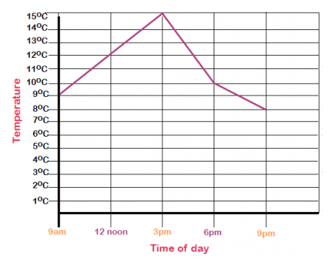

Look at the picture above and you will see a line graph showing the changes in temperature over a period of time. When asked to find the temperature at a specific time you need to go along the horizontal axis until you get to the requested time and then up from that point till you reach the line graph. From there you then need to go along to the vertical axis and read the temperature. In the picture above the temperature at 3pm is 15°C.

Now we move on to reading and interpreting information in timetables. This can be known as working out time intervals.
The information on the following website will help: https://www.theschoolrun.com/what-are-time-intervals
Timetables are what we use to find out what time something will happen. For example, a bus timetable tells us what time the bus should arrive at its destination. To work out the time interval, you look at the two times and work out the length of time between the two.
Destination | Departure time | Departure time | Departure time | Departure time
York | 08:45 | 09:10 | 09:40 | 10:10
Poppleton | 08:50 | 09:15 | 09:45 | 10:15
Harrogate | 09:18 | 09:43 | 10:13 | 10:43
Weeton | 09:31 | 09:56 | 10:26 | 10:56
Leeds | 09:56 | 10:21 | 10:52 | 11:21

I arrive at Leeds train station at 10:52. My journey to get here from York took me 1 hour and 12 minutes. What time did the train leave Leeds?
You need to work back from 10:52, first taking away 1 hour to get to 9:52. Then subtracting 12 minutes to get to 9:40.
Before you start, it is important you remember to use your knowledge of the 24-hour clock, such as 15:00 meaning 3pm. If a time interval is 85 minutes, you need to convert this to 1 hour and 25 minutes.
 | Train 1 | Train 2 | Train 3
Pieminster | 13:15 | 15:15 | 17:15
Steeplebank | 14:55 | ---- | 18:55
Westerfield | 16:10 | 17:55 | 20:10

If I take Train 2 from Pieminster to Westerfield, how long will my journey take?
Look at what time Train 2 left Pieminster (15:15). Look at what time Train 2 arrived at Westerfield (17:55). You need to work out the time interval between 15:15 and 17:55. Start backwards from 17:55, subtracting 2 hours to get to 15:55. Then subtract 40 minutes to get to 15:15. The journey from Pieminster to Westerfield took 2 hours and 40 minutes.
How long does it take to get from Steeplebank to Westerfield?
You can do this by looking at Train 1 or Train 3. If Train 1 leaves Steeplebank at 13:15 and arrives at Westerfield at 16:10, you need to work out the difference between these two times. Counting on from 13:15 to 14:00 is 45 minutes. The train arrives at Westerfield at 16:10 which is an extra 10 minutes, so the journey takes 55 minutes.
I have put some worksheets together where you have to interpret the line graph and tables and answer questions about them. I have also included some problem-solving questions to stretch your learning!
Happy Learning!
Mrs Plummer, Mrs Moss and Mrs Rowe

