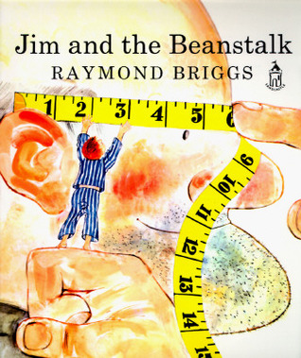

Writing task – Year 2

w/c 23.3.20 Retelling Jim and the Beanstalk

Your task is to retell the story of Jim and the Beanstalk in your own words.

Read the story or watch a retelling on You Tube - <https://www.google.com/search?q=jim+and+the+beanstalk+youtube&source=lmns&rlz=1C1GCEB_enGB868GB868&hl=en-US&ved=2ahUKEwiO2vq2nanoAhWN1uAKHdT6DEgQ_AUoAHoECAEQAA>.

Make a list of all the events that happen. Can you list the events in order?

Use the story map sheet provided to fill in what happens in the story. You can draw a picture for each part or print a picture to stick in each box.

Make sure the key events are in order!

Use the story map to verbally retell each scene. If you can, use a timer and have 30 seconds to retell each scene. You must stay on each scene for 30 seconds, retelling, then move on to the next one.

Have a look at the adverbials sheet, can you put an adverbial at the start of each scene?

Write the story in your own words. You can use the lined paper if you wish.

Have fun! I look forward to reading your story!