Perhaps it’s the impossibly beautiful beaches of Miami and the year-round sunshine, or of course those world-class theme parks, but anyone who visits are captivated by Florida. This pocket of paradise is truly infectious!  Orlando is like a world-class candy shop!  Named the theme park capital of the world, Orlando never fails to amaze with those hair-raising ‘coasters of Walt Disney World and beyond. Kids step into the movies at Universal Orlando Resort™ and golf fans are bowled over by its 170+ world-class courses.  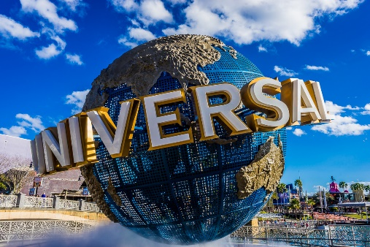 | In Orlando Florida everyone believes in magic!  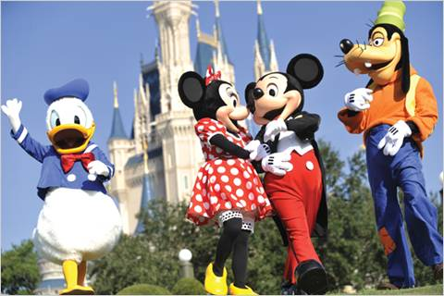  This is the Kingdom and you are the Royal Family!  With six Disney Parks, two exciting night-time entertainment districts, over 20 Disney Resort Hotels, a state-of-the-art sports complex and countless opportunities for dining, shopping, recreation and relaxation, it’s easy to see why Walt Disney World Resort is the holiday of your dreams. And these dreams can come true – just like magic. BOOK NOW!  Visit – www.virgingholidays.co.uk for more information and family deals! | Universal Orlando Resort™  Take your holiday to the next level at Universal Orlando Resort™. With three amazing theme parks - Universal Studios Florida™, Universal’s Islands of Adventure™, and Universal’s Volcano Bay™ water theme park, opening 2017 - spectacular on-site hotels and more. There are days and nights of endless fun to be had for every member of the family. Book your Orlando Flex Ticket now to get the full experience…  