Home Learning Challenges!
Geography  Create a birds eye view of your house. You might need 2 drawings as you have an upstairs and downstairs.  The picture will help.  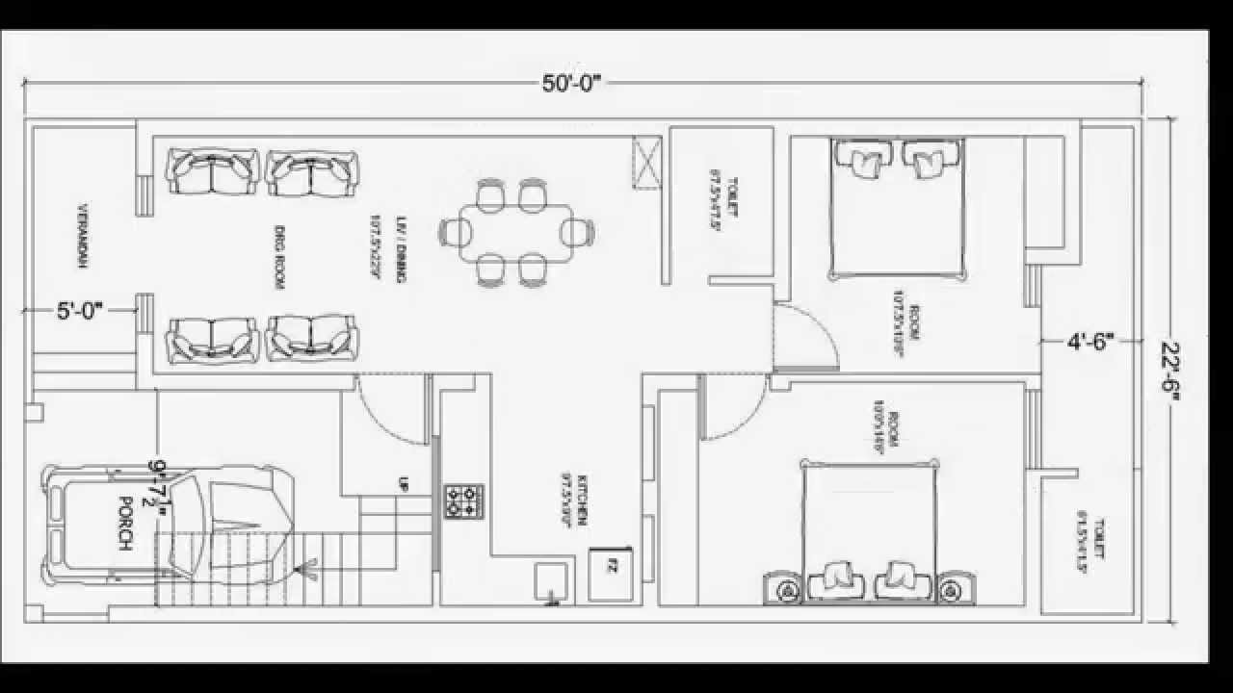 | History  Write a diary for one week about what you have done each day. What was the weather like? Did you go somewhere?  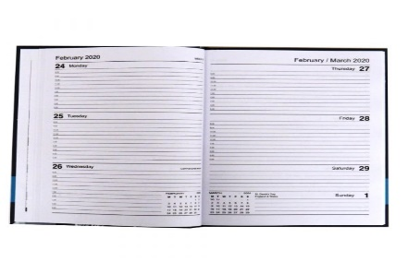 | Science – Materials  Design and make a parachute that you fly. For an extra challenge, make an egg holder so that your egg is protected when it lands.  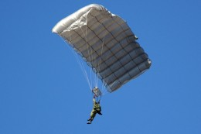
DT  Have a go at the recipes in your pack. If you are able to make some, take photographs as you make it and write some instructions as to how you did it. | PE  Follow this link and do an activity per day. You can do more if you like!  https://www.twinkl.co.uk/resources/twinkl-move/joe-wicks-twinkl-move | PSHCE  Mindfulness colouring: please complete the colouring in your pack. Be careful and keep it neat. Give your finished drawing to someone and tell them something positive about them. #bekind

